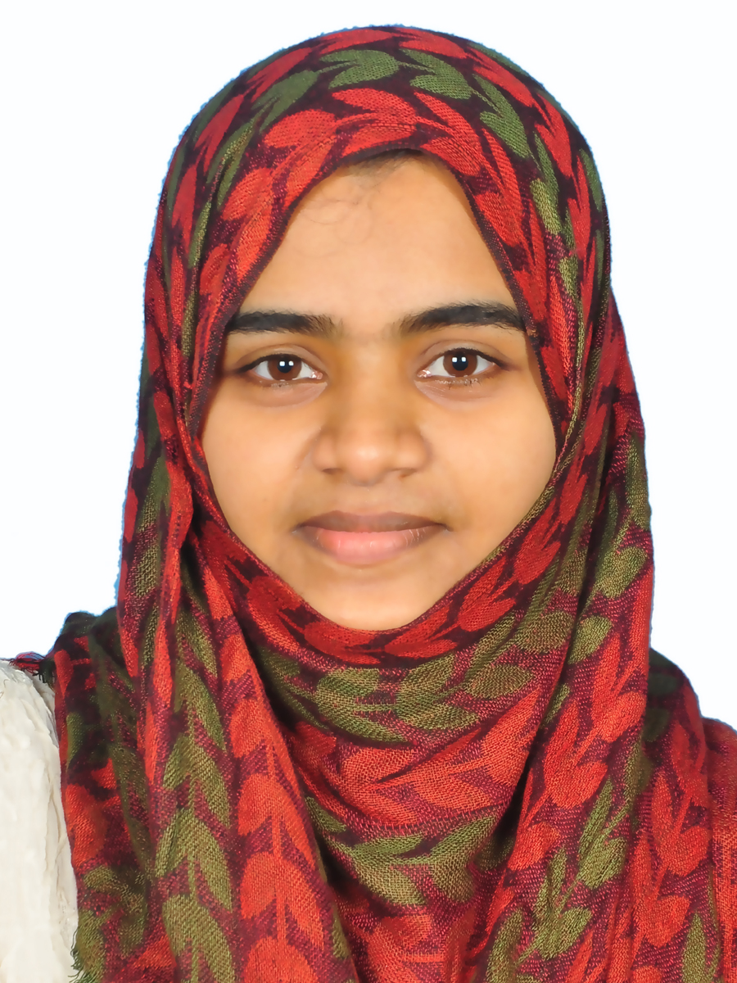

RANEEHA PANIKKA VEETTIL
# 302, Blue Diamond,
Al Mankhool, Dubai, UAE.
Mob: 056 8433646
Mail: reneehashibili@gmail.com

CAREER OBJECTIVE

- Seeking a suitable role in Human resources management, client relations or administration with a professional organization, which has a value based and ethical work culture, where I can contribute to its progression while growing professionally and personally.
- Achievement-oriented, diligent and committed professional with 5+ years’ eventful career studded with professional brilliance in strategic HRM, administration and management operations.
- Skilled in structuring and implementing innovative administrative policies/procedures to generate undivided commitment and dedication among the team. Core strengths in performing administrative and secretarial functions.
- Strong background in management planning, budgeting, staffing and facilities designed to enhance productivity and profitability.
- Demonstrated expertise in providing innovative human capital management solutions; policy/procedure administration, recruiting/hiring practices, personnel development, retention approaches, managerial support and negotiations management.
- Quick learner with a sharp, analytical mind. Self-motivated & organized; effective team player with excellent communication and interpersonal skills. Thrive in a deadline intensive environment, multi-task, perform under pressure and meet deadlines. Computer literate with excellent communication and email drafting skills.

Personal Strength

- Communication Skills
- Confident and Self-motivated & organized; effective team player
- Quick learner with a sharp, analytical mind.

Educational Qualification

- MBA in HR from Regional Management Institute under Bharathiyar University. India
- Bsc Bio Technology from J D T Islam arts & Science College under Calicut University. India
- Vocational Higher Secondary education from board of VHSE. India

Computer Skills: Computer literate with excellent communication and email drafting skills..

Work Experience

Sales Coordinator with telesales responsibility.

HDFC Bank Limited, Kottakkal Branch, Malappuram, India (June 2013-July 2014)

www.hdfcbank.com

Responsibilities

- Developing new clients and managing client related issues on a day today basis.
- Maintaining sales reports and statements.
- Develop the branch’s client base through bringing in new accounts
- Ensuring customer satisfaction through prompt and efficient customer service.
- Co-ordinated sales between 5 HDFC bank branches.

Unit Manager

Dr. Shaji’s MRI Centre, Tirur Branch, Malappuram, India (Sep 2008 – Sep 2010)



Responsibilities

- Taking care of the whole activities in a day
- Patience admission.
- Maintaining a pleasing relationship with customers till they leaving.
- Report typing.
- Report delivering on time to the patience.
- Checking day today accounts.
- Fund transferring to the bank account on time.
- Directly reporting to the MD about the whole collection and total number of cases in a day.
- Salary payment to the staffs.
- Leave sanctioning to the staffs from MD

Personal Details

Nationality: Indian.

Date of Birth: 30th April 1988.

Passport Number: N336972O expiring on 01/11/ 2025.

Marital Status: Married

Languages Known: English, Hindi, Malayalam and Tamil.

Declaration
I hereby declare that the above-mentioned information is correct to the best of my knowledge and I bear the responsibility for the correctness.

Date:
Place: Dubai RANEEHA PANIKKA VEETTIL

