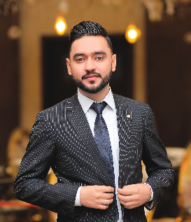

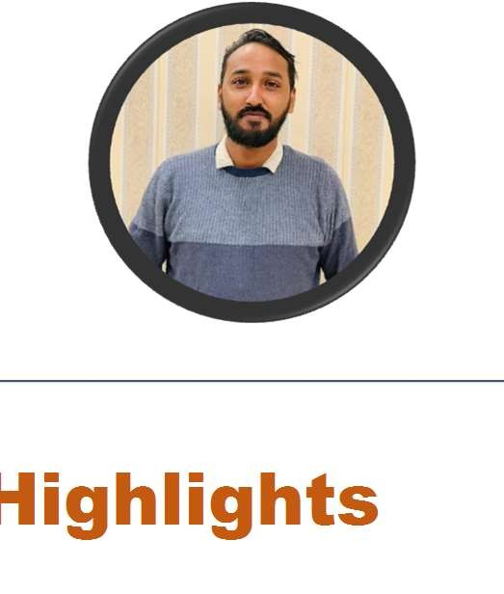5 years of experience in Medical Billing. Seeking a full time challenging position with a career-oriented company. I am dedicated, detail oriented, responsible, have the ability to work well with a wide range of personalities by way of excellent communication and interpersonal skills.

Job History
- Currently working as Billing Supervisor at PRG Medical Billing Company (March 2018 – present).
- Served as Accounts Receivable at Transcure Medical Billing. (April 2017 to March 2018).
- Served as Tele-Marketing at Tradex International (Oct 2015 to March 2017).

Experience
RCM
- Claim Submission and Rejections
- Remittance Management
- Payment Posting
- Denial, Appeals and Audit Management
- Reports Mechanism
- Eligibility Verification

Specialties:
Highlights
- External Audit
- Internal Audit
- Patient Calling
- Project management
- Strong decision maker
- Complex problem solver

Education
- MBA 2019
- M.A (Information Management) 2022

Tools
- CMS guidelines
- NCCI edits
- LCD & NCD’S
- Credentialing
- ERA & EOB Enrollment

  - Hospitalist

Muhammad Ilyas Ishaq
+92 (306) 874-8511
m.ilyas1075@gmail.com
  - Pulmonologist
  - Allergist

Software:
  - ECW
  - Officeally
- Physical Therapist
- Internal Medicine

- Advance MD
- Health Fusion

Hobbies
  - Sports
  - Social Volunteer
  - Web Browsing

