VIOLA MBATUDDE

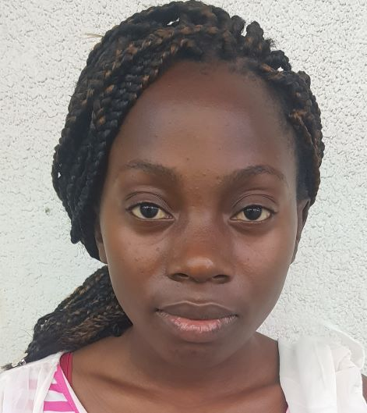  Mobile: +971582247203  Address: Dubai, UAE  - E-Mail mbatuddeviola8@gmail.com  POST APPLIED FOR :ANY SUITABLE JOB  PERSONAL DATA:  Date of Birth: 23/01/1996  Gender: Female  Nationality: Ugandan  Visa Status: Residence  EDUCATION:  High School Certificate in Uganda  COMPUTER SKILLS:  Internet, Email.  BEHAVIORAL CHARACTERISTICS  Commitment to quality and results  Responsibility Sincere in attitude  Presentation and leadership  Excellent problem solving skills  LANGUAGES SPOKEN  English  HOBBIES  Making Friends, Playing with babies, cleaning, Travelling and Music  REFERENCE  Available on request | OBJECTIVE:  Be part of a dynamic organization that allows me to actively contribute to its decision-making processes and assist in its growth, contribute to the growth and maintain/improve image and reputation. Willingness to communicate and share information with other team players, with an ability to learn and respond to changes with extreme flexibility to the surroundings without compromising with any of my principles and responsibilities to get to higher career and benefit of the organization.  SUMMARY OF QUALIFICATOINS:  - Good leadership, learning and language skills.  - Self-motivated and highly disciplined.  - Easily adaptable.  - Having emotional intelligence  - Having a positive and resilient attitude  - Strong emotional intelligence, efficiency and ethics  - Good communication, commitment and conflict resolution  CAREER PROFILE & EXPERIENCES:  - 2 year worked as cleaner /Housekeeping in Ajman UAE  - 2 years worked as maid/nanny in Oman  - 2 year worked as kitchen helper in dubai UAE  - 1 years in uganda as waitress  - 1 year worked as Warehouse assistant in Ceva, dubai UAE  - Part time job as waitress, cleaning, sales, Housekeeping, steward and Runner in UAE dubai  - I Hereby Confirm That All the Information Given Above is Correct to The Best of My Knowledge.  VIOLA MBATUDDE

