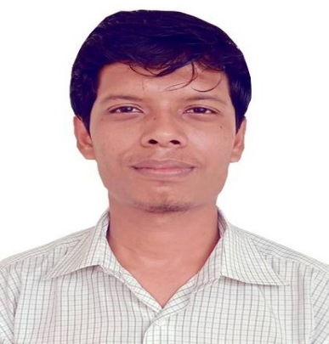
Curriculum Vitae of
MOHAMMAD YEASIN KHUKA

Present Address : Al Falah street AbudhabiU.A.EMobile :0562781611
E-mail: ykhuka@gmail.com
Career Objective
I want to develop my career with hard labor, using the best effort of my capability and honesty. I have interest to work in a suitable environment to express my creativity, enhance my knowledge and develop my career. I also want to be creative and innovative in my job field.
Special Qualification
Honesty and Sincerity
Self-motivated and Self-driven
Critical Analytical ability
Optimistic
Accepting Challenge
Strong Communication and Interpersonal Skills
Willing to work under pressure

Educational Qualification:
Exam Name | Institution | Subject /Group | Passing Year | Gpa | Board
BSC | Premier University | Computer science and Engineering | Running |  | Chittagong
HSC | Ashakane Awlia Degree College | Science | 2014 | 3.12 | Chittagong
SSC | Sermon School &College,Chittagong | Science | 2011 | 3.94 | Chittagong
Experience:
- CUSTOMERS SERVICE EXECUATIVE AT ZARA GALLERIA MALL ,ABU DHABI, UNITED ARAB EMIRATES.
- 2.CUSTOMERS SERVICE EXECUTIVE AT MASSIMIO DUTT YAS MALL,ABU DHABI, UNITED ARAB EMIRATES.
3. CUSTOMERS SERVICE REPRESENTATIVE AT SHEIKH ZAYED FESTIVAL ,ABU DHABI, UNITED ARAB EMIRATES.
4.CUSTOMERS SERVICE REPRESENTATIVE AT AL MANDOOS TRADING SOLE- PROPRIETORSHIP LLC. AL MURROR ROAD,ABU DHABI.
5.CUSTOMERS SERVICE REPRESENTATIVE AT ADIDAS AL WAHDA MALL, ABU DHABI.
6.CUSTOMERS SERVICE REPRESENTATIVE AT AL MARYYAH COMMUNITY BANK, ABU DHABI, UNITED ARAB EMIRATES.
***Expert in Windows XP, 7, 8, 8.1, MS Word, MS Excel, MS PowerPoint, 3D Studio Max,Auto- cad(2d and 3d),Internet Browsing.
Career and Application Information
Looking For : Entry Level Job
Available For : Part/Full-time job
District : Global
Language Proficiency:
Bangla, English, Hindi,Arabic
Personal Details
Father’s Name : Md Nurul Absar
Mother’s Name : Hosna Ara Begum
Permanent Address: Hathazari,Chattogram.
Present Address : Al falah street, Abu Dhabi, United Arab Emirates.
Nationality : Bangladeshi by Birth
Religion. : Islam
Date of Birth : 1/11/1995
Marital Status : Unmarried
Visa status : My Own Visa
Declaration:
I, the undersigned declare that the information provided in this curriculum is true to the best of my belied and knowledge and correctly describes my experience and myself.
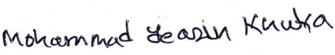
Date: Signature

