CURRICULUM VITAE
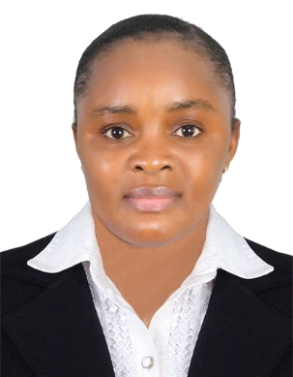

PERSONAL INFORMATION

Names: Amandine Ngassa Ayafor Epse Abubakar
CONTACT: +971545927621
EMAIL: halimaabu81@gmail.com
Date of Birth: 22 Jan 1987
Nationality: Cameroon
Visa Status: Husband Visa

CAREER OBJECTIVES
To secure an appropriate position, this will provide growth opportunities with effective utilization of my skills and experiences, also the opportunity to learn more in professional Atmosphere

ATLANTIS THE PALM JUMEIRAH DUBAI
Guest Service Agent/Customer Service: 1st Sept 2020- 31st August 2021
- Welcome guests and assist in checking them in, helping move luggage and guiding guests as needed
- Answer inquiries and provide information clearly and efficiently
- Monitor and maintain cleanliness, sanitation and organization of assigned work areas
- Meet with supervisor to review daily assignments and priorities
- Promoted positive guest relations to all individuals approaching the Front Desk
- Answered inquiries quickly and clearly while maintaining working knowledge of services provided

CAFÉ BATEEL- DUBAI FESTIVAL CITY MALL (Part Time, We Source)
Waitress: 4th Jan 2020- 30th August 2020
- Welcome and greet guests upon arrival
- Cleaned tables and floors of dining areas, ensuring that customers had a pleasant hygienic dining experience’
- Take orders from and serve food and beverages to patrons
- Perform consistent check-ins with patrons to ensure satisfaction and address complaints swiftly
- Answer questions about the menu and make recommendations when appropriate or requested
- Assist a team of hosts and hostesses by greeting, seating, and thanking customers
- Cleaned the polished furniture, shelves, walls and equipment
- Answered inquiries quickly and clearly while maintaining working knowledge of services provided

Strengths
- Speaks French and English languages
- Profound ability to multi-task and prioritize
- Excellent public relations, written and verbal skills
- Extremely organized and efficient at work
- Superb communication and interpersonal skills
- Excellent organizational and time management skills
- Flexible and adaptable to change background
EDUCATIONAL BACKGROUND
2012–2014 Cameroon Bilingual Centre for Information Technology and Consultancy (CITEC)
Diploma in Marketing
2010-2012 – English High School
High School Certificate
LANGUAGES
Good Mastery of English & French Languages Spoken and Written
Computer knowledge
ERP,SPSS, MSP, Excel, Microsoft word, Sage Sari

