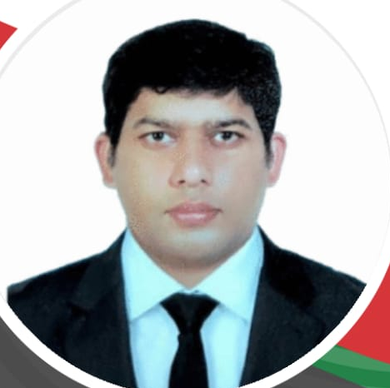
YASIR MEHMOOD

Phone: +971 529720576
E-mail: yasirmehmood1986@yahoo.com
Locations: Dubai

Objectives
To work for a result-oriented Firm where I get a chance to contribute my skills for the benefit of organization as well as my personal skill.

Academic Qualification
Degree | Institution | Year
BA | UNIVERSITY OF GUJRAT | 2010
FA | BISE GUJRANWALA | 2004
MATRIC | BISE GUJRANWALA | 2002

Achivements
Worked as a sales Executive Coordinator achieved the following feasts for United Bank Limited
- Won 3 consecutive Foreign tours for Dubai, Thailand and Europe conventions
- Persistency Bonuses
- Won a motorcycle
- Secured 3consecutive 2nd position Pan Pakistan in Bancasurance.

SKILLS

- Client Development
- Customer Relationship
- achieving personal and business goals
- Dedicated self-driven, focused and result oriented
- Sales promotions

COMPUTER SKILLS

Microsoft Applications (Word, Excel, PowerPoint, Outlook, Internet based Applications)

PROFESSIONAL EXPERIENCE

CURRENT POSITION:
PURE HEALTH LLC DUBAI
Working as a Customer Service Associate at T3 Dubai International Airport
(Mar 2020 to Till Date)

Eastern Federal Union (EFU) Insurance Company Limited- Pakistan (Leading private sector life insurance Company of Pakistan)
Executive sales Coordinator - ( May 2013 to Sep. 2019)
Joined as Bank assurance sales Consultant (UNITED BANK) in EFU in January 2012 and due to efficient sales qualities and 100% achieving of all sales goals I was prompted as Executive Sales Coordinator in April 2013.

Roles and Responsibilities:
- Manage as sales team responsible for hiring support members and providing them with
the team vision and goals.
- Attending all customer inquiries ensuring all producers are in line with the banks turnaround time.
- Actively supporting the bank sales team.
- Daily sales reporting to the bank preparing and maintaining all related MIS

EFU Insurance Agent - (Feb 2012- April, 2013)

Roles and Responsibilities:
- Contact potential customers by Bank referrals, cold calling, and networking.
- Convince prospective customers to take our policies and plans.
- Collect information from clients on their risk profiles in order to offer them the proper solution.
- Explained the features, benefits, and advantages of different types of policies to promote the sale of insurance plans.
- Implemented effective marketing strategies to sell new insurance contracts.
- Retain continuous awareness of transactions, sales and terms and keep relative records.
- Fulfill all company-established policy obligations.
- Sell a variety of insurance products to businesses and individuals.
- Answer any questions or concerns policy holders have with their insurance claims.
- Evaluate clients’ current insurance policies and suggest changes.
- Present different insurance plans suitable for individual clients.
- Maintain clients’ records and database.
- Contact old clients to renew the existing plans.
- Check insurance claims to solidify trust and safeguard reputation.
- Calculate premiums of different types of insurance based on risk assessment.
- customers
- Presented claims for insurance benefits when dealing with accidents and natural disasters.
- Sent reminders of premium payments and notified customers of any rate changes.
- Working with the team members on specific tasks and assignments.

- Father’s Name | - Tariq Mehmood
- Date of Birth | - 24th April 1986
- Marital Status | - Married

