Sana Anwar
- Mobile: +97152 230 2742 E-mail: sana_anwar2220@hotmail.com

EXECUTIVE SUMMARY
Customer Service, Administrator and Sales Co-ordinator professional with over 7 years of practical experience within large group of organizations. Possess expertise in customer service and Co-ordinator. Proficient in multi-tasking, worked with different job roles and acquired a comprehensive grounding in a broad mix of disciplines, facing challenging atmosphere and performing in multicultural work environment, combining business management knowledge with good commercial knowledge.

PROFESSIONAL EXPERIENCE
Al Gurg Fosroc LLC Sales Co-ordinator
Dubai, UAE June 2014- Present

- Maintaining a healthy relationship with existing customers while opening up fresh customers.
- Update Quotation & CRM on Microsoft Dynamics AX.
- Providing sales and administrative support involving efficient handling of top and confidential agreements.
- Supporting the sales team in attaining sales targets.
- Communicating with regional sales team for status of order and position of sales.
- Providing inputs and ideas into marketing enterprises and subsequently promote them and monitor responses.
- Preparing monthly, weekly or daily sales analysis.
- Preparing proposals, agreements, sales reports, and presentations.
- Updating the status of sales order in the database or computer.
- Collecting, analyzing, evaluating and accounting the information in order to increase productivity of sales.
- Monitoring the trends and evaluating the performance assessed against monthly sales goals.
- Maintaining an efficient work environment.
- Promoting the facilities of the organization to fresh and existing customers through a proactive approach.
- Coordinating and responding to all requests of internal meetings.
- Assisting in the implementation of sales strategy as prepared by the Sales event manager.
- Price list maintenance: updating Margin.
- Price approvals processing.
- Tele Sales

Katana Advertising Administrator
Dubai, UAE March 2013- January 2014

Administrator
Frontlines and coordinated with different authorities; Supervise housekeeping staffs with regards to new assignment and their payrolls.

- Process all calls (inbound and outbound) from customers in an efficient and professional manner to satisfy: pricing enquiries/verbal request for quotation, stock availability, delivery status and contacting/up-dating field personnel as per communication policy
- Solving customer’s queries and reporting problems to the sales department. Issuing quotation and forwarding to the customer. Handling Cash flow and updating day-to-day reports.
- Process facilities invoices for approval and payment.
SKILLS AND SPECIFICATIONS
- Good Oral and written communication skills.
- A high tolerance of stress and enjoys responsibilities.
- Solid problem-solving and business acumen skills.
- Ability to negotiate and discuss value propositions.
- Quick learner with good grasping ability
- Lead & work as a team in an organized way.

EDUCATIONAL BACKGROUND
- Secondary School Education (SSC I – II) Year 2007
Pakistan Islamia higher secondary school Sharjah,UAE

- Higher secondary Education (HSSC I – II) Year 2009
Pakistan Islamia higher secondary school Sharjah, UAE

- Master in Business Administration Year 2017-2020
Aim Business School University Sharjah, UAE

ACHIEVEMENTS
Digital Badges
- MBA Unit - Corporate Strategy & Responsibility August 26, 2020

- MBA Unit - Strategic Organisational Change May 19, 2020

- MBA Unit - Managing Operational Improvement May 19, 2020

- MBA Unit - Leading, Managing & Developing People Online May 11, 2020

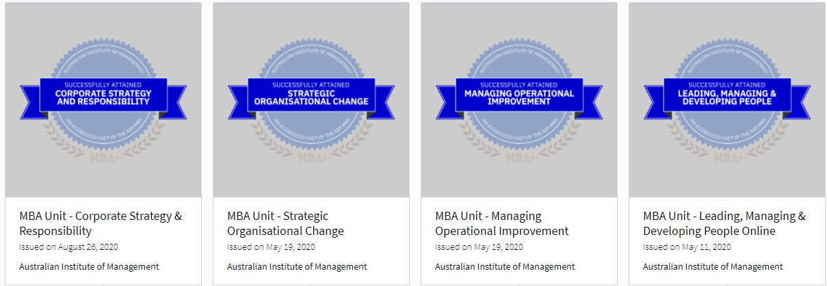

 |  | PERSONAL DETAILS
- Visa Status | : | Company Visa (Transferable)
- Date of Birth | : | 22nd May 1989
- Languages | : | English, Urdu, Hindi
- Nationality | : | Pakistani
- Marital Status  - Driving License | :  : | Single  Valid U.A.E

