
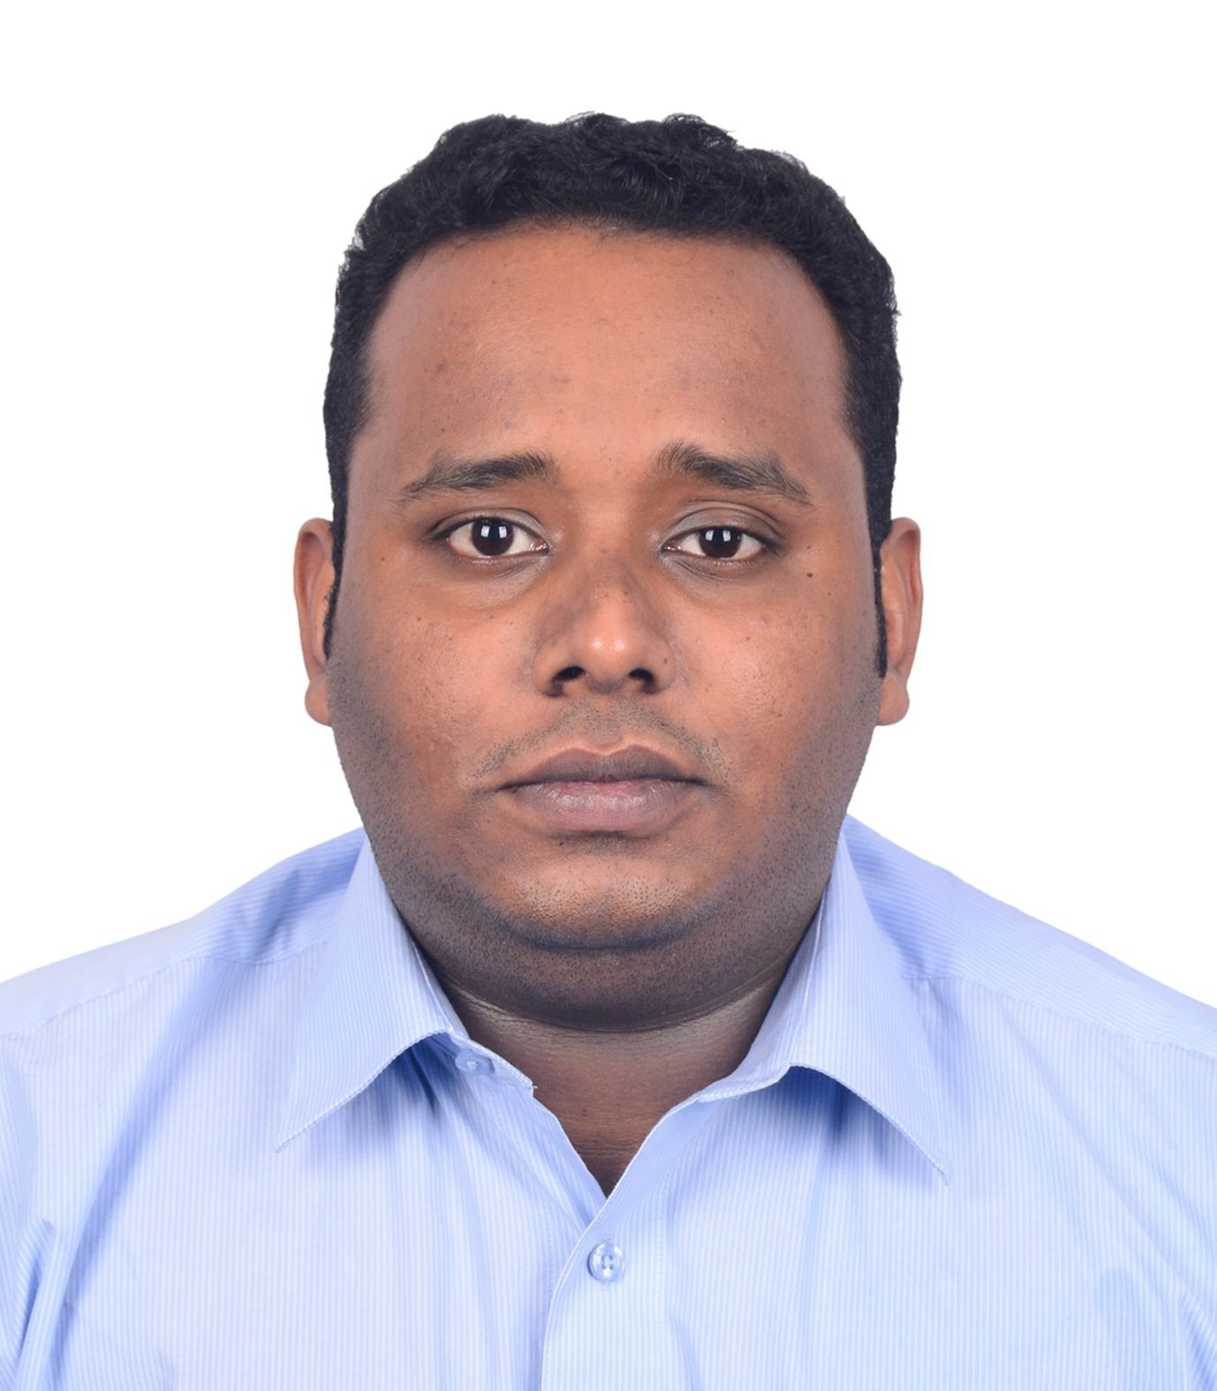
DINSE JOSEPH SAJI
Address: Dubai , UAE
Nationality: Indian
Contact Number: +97156 193 7872
Email: dinsesaji98@gmail.com

Career Objective

To secure a responsible career opportunity to fully utilize my training and skills. To gain experience while making a significant contribution to the success of company.
Key Competencies / Skills
- Time Management
- Microsoft Office proficiency
- Customer relations & Communication
- Interpersonal Skill
l
Employment History
Now working as Front Office Assisatant at Lou Lou a beach resort, Sharjah al khan –Dec 2021 –( Present)
- Answer and direct phone calls
- Organize and schedule appointments
- Plan meetings and take detailed minutes
- Write and distribute email, correspondence memos, letters, faxes and forms
- Assist in the preparation of regularly scheduled reports
- Develop and maintain a filing system
- Update and maintain office policies and procedures
- Maintain contact lists

Sales Executive at Goodwill Enterprises, Kerala, India - May 2020 to September 2021 Roles and Responsibilities:
- Negotiating on price, specification with buyers
- Challenging any objections with a view to getting the customer buy the product
- Discussing special promotions

- Checking quantities of goods of display and on stock
- Recording sales details on computer system

Front Office Assistant at Somatheeram Resort , Kerala, India – August 2019 to March 2020

Academic Qualifications

  - Completed Bachelor of Business Administration at Jaipur national university
  - Diploma in Aviation, Hospitality and Travel Management from Frankfinn Institute of Airhostess Training, July 2019
  - Technical Higher Secondary Education Certificate, Board of Higher Secondary Examination, Kerala, March 2017
  - Secondary School Leaving Certificate, Central Board of Secondary Education Delhi, March 2015
Certifications
  - Microsoft Excel Techniques

Additional Information and Personal Profile

Date of birth : 12/10/1998

Visa : company visa

Hobbies : Traveling, cooking
Marital Status : Single

Languages Known : English, Malayalam Reference : May be furnished on demand Driving License : 915569

