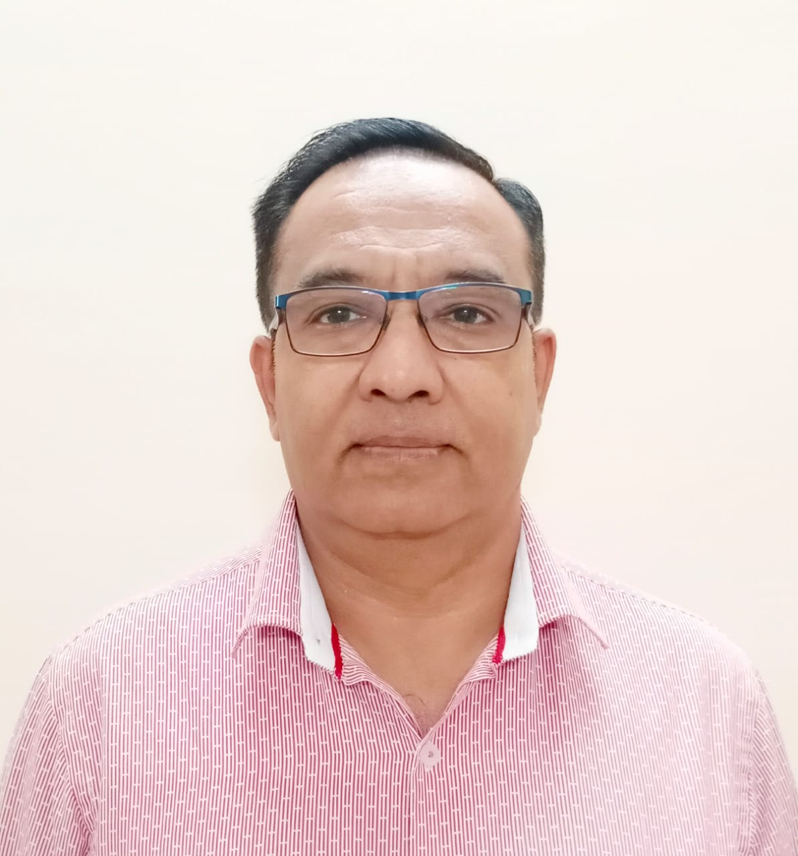

Mohamad Arif Hasan Mansuri
Mob: +971557076350.
Email: mansurimohd_arif@yahoo.com

CAREER PRECIS

- A result oriented professional with rich experience in Team Management, Sales & Marketing.
- Significant experience in executing operations pertaining to developing business plans for the achievement of these goals.
- Proficient in cementing healthy relationship with customers & associates for generating business as well as leading & training field force towards accomplishing business and corporate goals.
- An effective communicator with excellent relationship building & interpersonal skills. Possess a flexible & detail oriented attitude.

AREAS OF EXPERTISE
Team Management
- Determining training needs & conducting programmes to enhance efficiency in overall operations towards the accomplishment of overall corporate objectives.
- Leading and managing the performance of the team members to ensure efficiency in business operations, recruiting team and meeting of revenue and sales targets.
- Monitoring the performance of team members to ensure efficiency in operations and meeting of individual & group targets.
Sales & Marketing / Business Development
- Driving marketing initiatives & managing the frontline sales team to achieve goals. Initiating and developing relationships with target organizations for business development.
- Conducting competitor analysis by keeping abreast of market trends and competitor moves to achieve market share metrics.
Customer Management
- Supervising customer service operations for rendering quality services, providing customer support by answering queries and resolving their issues.
- Conducting effective product presentation & providing after sales services.
- Building and maintaining healthy business relations with high net worth and corporate clients, ensuring high customer satisfaction matrices by achieving delivery & service quality norms.

Sales Promotion
- Framing strategies for establishing greater awareness about company & other scheme operations.
- Implementing the pre/post launch sales promotional & merchandising activities for the brand development.
- Making effective visual display of the product

SKILLS
- Experience in Retail business, Sales & Retail operations.
- Good ability to Analyze & interpret information.
- Attractive merchandising display.
- Competition mapping
- Inventory management.
Self Employed.
2014 - Present.
Aisha Beauty Saloon-U. A. E.
~Oversee daily salon operations
~Hire and train beauticians, as needed
~Organize employees’ shifts, considering peak times and seasonality
~Order beauty products, like creams and essential oils and replenish stock
~Arrange for regular maintenance services for all equipment
~Apply hygiene practices across all beauty stations
~Ensure all beauty treatments meet high quality standards
~Maintain staff records, including salaries and working schedules
~Promote services, products and discounts on social media
~Receive payments from clients and track all transactions
~Keep updated records of costs and revenues (e.g. daily, monthly and quarterly)
~Run online competitions and offer discount packages to attract new customers.

Showroom Manager
Sun and Sand Sports-U.A.E
Since 2002 to 2014.
Key Responsibilities as Senior Store Manager:
- Responsible in supporting Operations Manager for efficient implementation & monitoring of store sales activities in compliance with the system, structure, standard, policies & procedures of the company.
- Support Operations manager in conducting monthly Store Visit Report, Store Audit Report & Peak Trading Report.
- Monitor & continuously seek to understand commercial environment, local trading patterns, competitor’s activities & market trends in the retail sector & their impact in the store.
- Delivering highest level of motivation & development of team members & ensures individual & store compliance with all company & business partners regulations & procedures.
- Ensure that job rotation is implemented in the store giving each staff member an opportunity to move to different section in the store.
- Deal with staff grievances in accordance with the company policy
- Training and Development of the team members to understand the process & its execution.
- Ensure that all staff are appraised in line with company policy.
- Support company in opening new stores.
- Ensure safety in work area.

Showroom Manager
M.H.Al Shaya-U.A.E.
Since 1995 to 2002.
Key Responsibilities as Store Manager:
- Achieving & exceeding the targets set for the stores.
- Monitoring the day to day store operation as per the defined process/policy.
- Maintaining appropriate level of stocks in the store to serve customers properly.
- Ensure 100% compliance to planogram, Visual merchandising & merchandising plan.
- Continuously communicating with all departments & maintaining high performance and team culture of the organization.
- Achieving the defined level of customer service in the store.
- Leading and managing the team members to ensure efficiency in Business Operations.
- To ensure all customer feedback/Complaints are satisfactorily handled.
- To discovery ways to bring customers to the store and ways to convert these into sales.
- To ensure that the standards of service, Design, Merchandising are maintained in accordance.
- To have a good understanding of who are the competitors and what are the levels of business at other competitor outlets.( Competitor knowledge)
- Guiding, coaching, co-ordination with various other functions (i.e. Marketing, HR, Training etc.)Within store and at head office for greater back-end support.

Academic Credentials

- H.S.C. Gujarat Secondary Education Board,Ghandinagar in 1985

Technical qualification
- Basic Knowledge of computer

Personal Details

Gender : Male
Nationality : Indian
Marital status : Married
Language known : English, Arabic, Hindi, Marathi, Gujarati & Urdu.
Driving Licence : Valid U.A.E. driving licence.

The information furnished above is true and correct to the best of my knowledge and the no statement has been made up and untrue. I am responsible for its accuracy.

