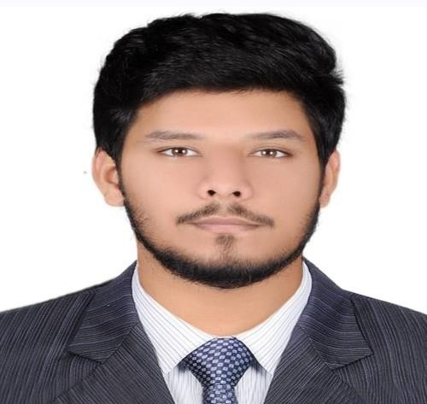

PROFESSIONAL SUMMARY

To be an integral part of an organization, which will enable me to utilize my potential to the fullest in order to give the best to the organization, demonstrate and improve my strengths towards the betterment of the organization and grow with the company. Looking for a diversified experience with any multinational environments and to make use of opportunities.

AHMED SYED USMAN

DOB: 19/09/1996
Gender: Male
Nationality: Pakistan
Mobile: 0525894255
Email: Talentoffutre65@gmail.com
Address: Sharjah
Driving license: Yes

SKILLS
- Creativity
- Enthusiastic
- Organized
- Flexible
- Problem solving
- Team work skills
- Public speaking
- Microsoft office

LANGUAGE
- English
- Arabic
- Urdu EDUCATION
- CROMWELL EDUCATION UNIVERSITY OF UNITED KINGDOM
- Holding A Diploma Degree of BTEC Level 3

INTERESTS

- Photography
- Traveling
- Learning languages
- Workout
- Sports
- Video games

WORK EXPERIENCE

HEALTHCARE LAB TECH 2022 (ALFUTTAIM HEALTH-HUB CLINIC) UP TO DATE)

- Sterilize equipment in sterilization room
- Do health checks.
- Re-stock consulting rooms.
- Process lab samples.
- Take blood samples and hand them over to the driver for the lab
- Order inventories for the clinic

PATIENT RELATIONS EXECUTIVE (CUSTOMER SERVICE EXECUTIVE) ALFUTTAIM HEALTH-HUB CLINIC (2021)

- To meet patient and ensure proper services from all the departments
- To inform concerned support staff to resolve patient complaints.
- To follow up pending investigation.
- Maintaining a positive, empathetic, and professional attitude toward customers at all times.
- Responding promptly to customer inquiries.
- Communicating with customers through various channels

EMIRATES POST GROUP (Sharjah Central Post Office) Customer Service, Sales, Cash handling

- Deliver excellent customer service and demonstrate a high degree of professionalism.
- Achieve high levels of sales performance and results.
- Know the products inside and out and stay fresh with new merchandise, trends, and competitive activity.

OTHER EXPERIENCE

ORGANIZATION: AMAZON

POSITION: Warehouse logistics assistant

ORGANIZATION: EMAX (DUBAI MALL) (MIRDIF)

POSITION: Merchandiser/IT department for Dell laptops

