WORK HISTORY

Health Hub Clinic, (Al Futtaim), Dubai, UAE
Patient Relations Executive. (Jan 2022 To MAY 2022)
- Reviewing patients accounts, identifying delinquent accounts, and collecting overdue payments.
- Assisting patients in filling out patient history forms, consent forms, and payment contract forms, when necessary.
- Receiving and processing cash and credit card payments for medical service rendered.
- Preforming administrative and clerical duties, such as filling paper works, when necessary.
DIALOG BUSINESS SERVICES PVT LTD, SRILANKA. Senior Customer Service Associate. (April 2017 To April 2018)

- Handling enquiries from customers in person, over the phone and online and resolving complaints
- Measuring customer satisfaction and working to targets.
- Coordinating and collaborating with cross-functional teams to ensure quality services to customers.

First Source Dialog Solutions LLC, Srilanka. Customer Service Associate. (March 2015 to March 2017)

Ceylinco Life Insurance, Colombo, Srilanka. Sales Executive. (2014 Jan to 2014 DEC)

Maax Pharmaceuticals, Colombo, Srilanka. Accounts Assistant Cum Cashier. (2011 Jun to 2013 Dec)

EDUCATIONal qualification

- General Certificate in Advanced level Examination. Successfully passed Advanced Level
- AAT foundation level Completed
- The Srilanka Insurance Institute Affiliated to the Chartered Insurance Institute, UK (SLII) Successfully Passed
- Diploma in ICT Successfully Completed

KEY SKILLS AND CHARACTERISTICS

Strong interpersonal & communication skills • MS Office Suite • WPM: 90 • Ability to work collaboratively as part of a team • Problem Solving • Leadership • Meticulous attention to detail • Excellent Organizational skills • Poised under pressure

PERSONAL DETAILS

- Full Name - Krishika Arumugam
- Gender - Female
- Civil Status - Married
- Date of Birth -19.01.1992
- Religion -Hindu
- Nationality -Srilankan
- Visa Status -Sponsorship

References
Mr. Chandrakanth
Senior Accountant
Al Futtaim trading Company LLC, Dubai, UAE.
Chandru2uae@yahoo.com
Mobile:0552708029

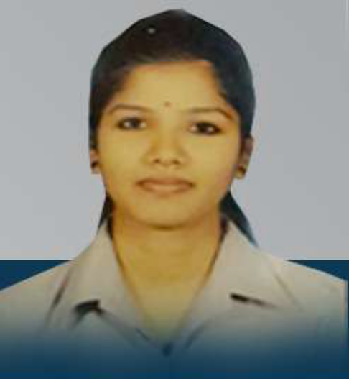

krishika arumugam

PROFILE
Ability to learn new skills quickly and adapt to different environment with confidence. A Co – operative and supportive team member who enjoys working with others to archive common goals. A polite and friendly personality with strong interpersonal skills and the ability to relate comfortably with people at all levels.

CONTACT

krishiarum@yahoo.com
https://www.linkedin.com/in/krishika ‾ arumugam ‾ 602371169
009712509719535

ledership activities

- Member of Leo Club
- Prefect in School

LANGUAGE

- English
- Tamil
- Sinhala

PROFESSIONAL SKILLS

- Knowledge of HIS/CCBS/CCRM/SIEBEL/ ORACLE
- MS Office
- MS Word
- MS Excel

