

Shaikh Kashif

Seeking assignments in Customer Service & Quality Assurance with a leading organization of repute.
shaikhkashif18@yahoo.com
+971543557116 || +91-9819918169

Profile Summary

- Customer & Quality Service Specialist offering nearly 8 years of a successful career with diverse roles distinguished by commended performance across Financial Services, Insurance and BPO domains
- Deftness in monitoring quality of high-quality customer experience, elevating customer satisfaction, while adhering to SLAs & managing cost-effective operations
- Proficient in capability development with passion for designing process solutions that resulted in integrated customer experience and improved operational performance
- A proactive leader and planner with expertise in managing & expanding client base for augmenting turnovers and achieving desired targets / goals; skilled in analysing current data and financial statements of individuals or firms to determine the degree of risk involved
- Proven record of excellent performance in delivering breakthrough business results, leading continual improvement initiatives and realization of changes required

Education

- BBA from Jaipur National University in 2019
- Diploma (DNS) from MMTI, Mumbai, IMU in 2011; secured 82.5%
- 12th from V.W.A. Junior College, Versowa, Mumbai University in 2006; secured 82.8%
- 10th from Vidyanidhi, Mumbai, Maharashtra Board in 2004; secured 81.8%

Training

- Trained Lean Yellow Belt Professional and executed project

Core Competencies

Customer Lifecycle Management | Quality Assurance | Reporting & Documentation
Process Management | Performance Management | People Management

Career Timeline
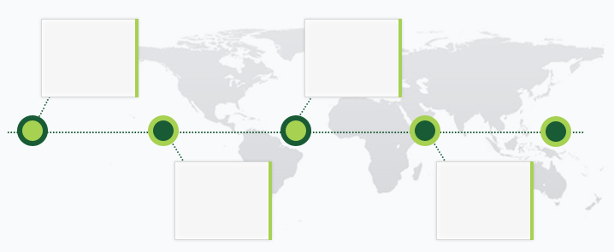
2012 to 2013
East India Shipping/RPSL
2014 to 2016
Tech Mahindra Business Services
Since 2016
Capita Dubai Fz Ltd.
2013 to 2014
Serco BPO Services Ltd.
Work Experience

Nov’16 till date
Zurich International Life Ltd. (In the Payroll of Capita Dubai Fz Ltd.), Dubai
Joined as Help Point Consultant and currently working as Technical Overseer - Quality Control
Role:
- Managing customers and broker queries through calls, E-Mails and client visits
- Performing quality checks on calls, E-Mails and client visits
- Working on new processes and implementing ideas
- Mapping client’s, identifying improvement areas & implementing measures to maximize customer satisfaction levels
- Setting out quality standards for various operational areas, ensuring a high-quality customer experience while adhering to the SLAs and work processes
- Monitoring the overall functioning of processes, identifying improvement areas and implementing adequate measures to maximize customer satisfaction level
- Leading, mentoring & monitoring the performance of team members to ensure quality on calls and E-Mails
- Acting as the Trainer for new joiners and existing staff

Highlights:
- Automated several processes which helped in reducing time and expenses
- Focused on problem management and automation, enabled reduction in incidents and Service Requests (SRs)
- Steered implementation of process improvements thereby improving performance of service partners
- Excellent track record of consistently maintaining Customer Satisfaction Index across markets, by providing recommendations for service improvement and by establishing & implementing best practices

Previous Experience

Aug’14 – Sep’16
Tech Mahindra Business Services, Mumbai as Customer Relations Advisor

Apr’13 – Aug’14
Serco BPO Services Ltd. (Barclays Plc.), Mumbai as Customer Relations Advisor

Jan’12 – Dec’12
East India Shipping/RPSL, Beirut as Deck Cadet

Personal Details

Date of Birth: 15th April 1989
Nationality: Indian
Passport Details: No. J9060001 (Dt. of expiry 9th June 2021)
VISA Details: Employment VISA
Marital Status: Married
No. of Dependents: 1
Address: #304, Oman House, Al Qusais, Dubai
Languages Known: English, Hindi || Urdu & Arabic (basic)

