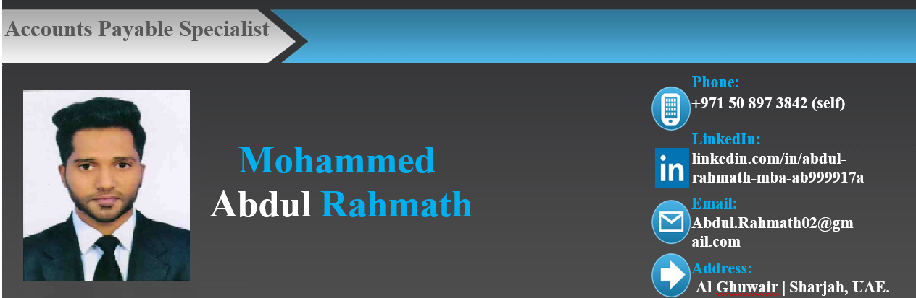

OBJECTIVE:
Seeking a challenging career in the field of Accounting, Finance & Administration to explore my expertise & work towards achieving the organizational & personal goals.

DOMAINS OF INTEREST:

Finance and Accounting

Accounts Payable -Invoice Processing
- Accounts Payable – Customer Service
EDUCATIONAL QUALIFICATIONS:

M.B.A (Finance) (2015-2017) | Academy of Management Studies  (Affiliated to Osmania University, Hyderabad, India)
B.com (Computers) (2012-2015) | St. Paul’s Degree College  (Affiliated to Osmania University, Hyderabad, India)
Intermediate (12th)  (2010-2012) | MS Junior College  (Board of Intermediate Education, Hyderabad, India)
S.S.C (10TH) 2010 | S.M Educational Academy  (Board of Secondary Education, Hyderabad, India)
CERTIFICATIONS:
  - Diploma in Financial Accounting from the Institute of American Accounting School of India
  - Excellence in MS-Office (MS-Word, Advance Excel & PowerPoint)

AWARDS AND ACHIEVEMENTS:
  - Bronze Award for the best performer in a quarter
  - Appreciation from Business for providing the accurate and timely resolution
  - Trained to team members for process improvement

JOB EXPERIENCE: [3]

Accounts Payable Specialist
May, 2021 to present

DUPONT PRIVATE LIMITED
Dow Chemical DuPont of Nemours, Inc

Roles and Responsibilities:

Help Desk Domain:
  - Providing resolution to business and vendor on all AP queries received via VSD ticketing tool, Emails and JIRA processing tool by searching in ERP SAP, Kofax Mark view in Workflow and Ariba
  - Taking Business / Vendor calls and resolve query on call within a specified time to gain Good Customer Satisfaction feedback
  - Working on Ad-hoc and urgent emails received from stakeholders or vendors and track It until payment is done
  - Own additional activities like Statement Reminders, VSD Reports, and sending CSAT Survey emails to Business to seek Feedback which is a KPI
  - Verifies vendor accounts, monthly statements and related transactions

Invoice Processing Domain:
  - Processing invoices in SAP of US, Canada, UK and EMEA region
  - Process Invoices in the Company Approval workflow system
  - Validate invoices received from customers processed and routed for approval and payments
  - Co-ordinate with the customers Invoices pending for submission and post
  - Invoice follow-up requests Update internal team for Customer Payment status or any concerns
  - Worked on emails received from Clients and Internal Teams
  - Support on Month end Accruals

JOB EXPERIENCE: [2]

Process Associate
May, 2019 to May, 2021

GENPACT PRIVATE LIMITED
Business Process Management Industry

Roles and Responsibilities:

Invoice Processing Domain:
  - Processing invoices in SAP of US, Canada, UK and EMEA region
  - Worked on emails received from Clients and Internal Teams
  - Tracking, reviewing, approving, and issuing invoices
  - Validate invoices processed and routed for approval and payments
  - Support on Month end Accruals

Help Desk Domain:
  - Providing resolution to business and vendor on all AP queries received via ServiceNow tickets and Cora cases by searching in ERP SAP, Kofax Mark view, Service now, Cora case Workflow and Ariba
  - Taking Business / Vendor calls and resolve query on call within a specified time to gain Good Customer Satisfaction feedback
  - Own additional activities like Statement and Reminders (STNR’s) Queue, OCR Fallouts and sending CSAT survey emails to Business to seek Feedback which is a KPI

JOB EXPERIENCE: [1]

Assistant Accountant
July, 2017 to December, 2018

BAIG & ASSOCIATES
Chartered Accountant & Tax Consultant
Worked as an Assistant accountant managing live projects with clients and internal team
And maintaining day to books of accounts in Tally ERP 9 and other Accounting Software
Checking to make sure payments amounts and receipts amounts matches with bank statement

STRENGTHS:
- Quick learner
- Flexibility and adaptability
- Team player with positive attitude
- Always handled stress and pressure in a positive way
- Organizational skills and ability to manage deadlines
- Team working ability and active listening
- Excellent written and verbal communication skills
- Highly trustworthy, discreet and ethical

SOFTWARE SKILLS:

SAP | MS-OFFICE (Advance Excel) | Wings | GEP Smart Tool
Ariba | (VLOOKUP’s, Pivot Tables, SUMIF) | Cora Case Tool | SAP Concur
Kofax | Tally ERP 9 | Outlook Express | VSD Ticket Tool
QuickBooks | Service Now | Peachtree | E-Commerce & E-Payment

PERSONAL DETAILS:
Father’s Name : Mohammed Abdul Ahmed
Date of Birth (Age) : December 16, 1993 (27)
Gender : Male
Nationality : Indian
Religion : Muslim
Marital Status : Single
Languages : English, Hindi, Urdu & Arabic (Reading, Writing & Speaking)

DECLARATION:
I hereby declare that all the details mentioned above are in accordance with the truth and fact as per my knowledge and belief.

Place: Sharjah, UAE
Date Mohammed Abdul Rahmath

