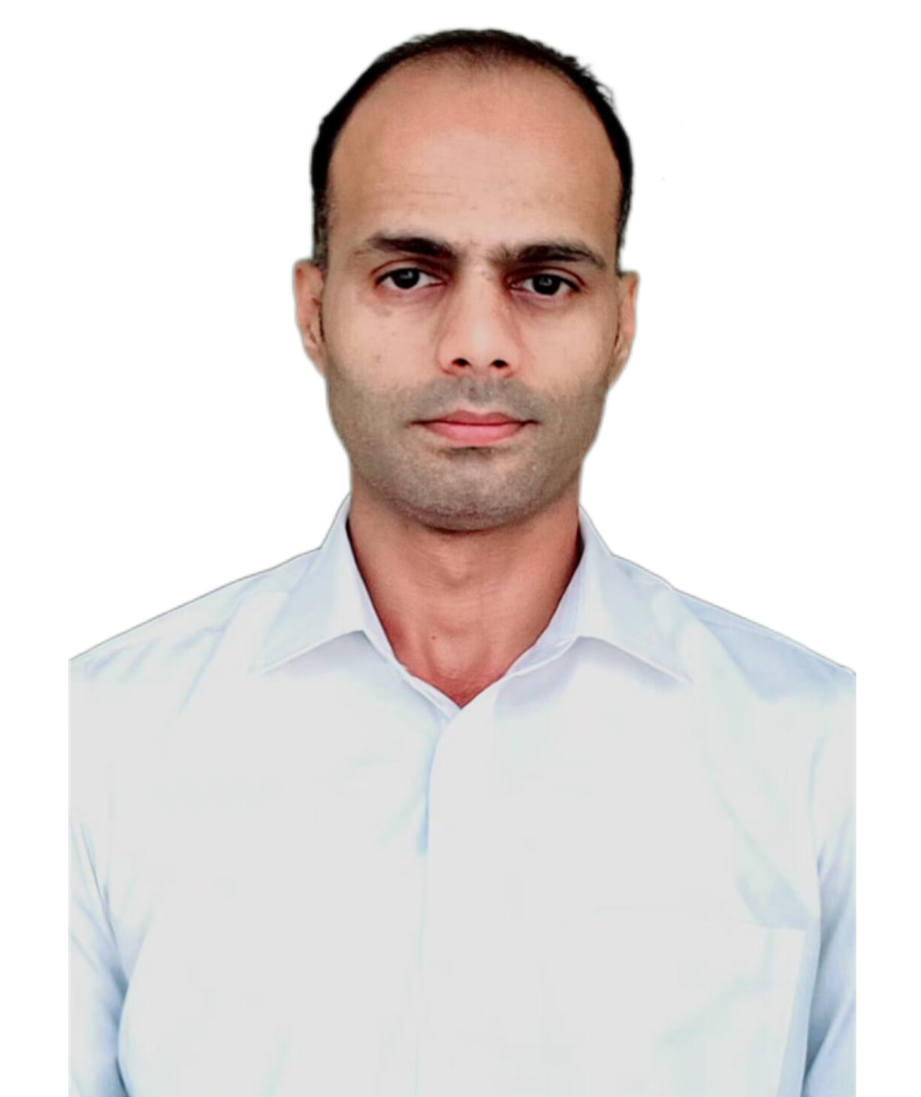 | Raja Ghufran Ayub  Customer Service Representative
CONTACT  PHONE:  971 55 260 6536  EMAIL:  ghfrangakhar@gmail.com  SKILLS  Driver(5years)  - Customer Service  - Leadership skills  - Communication Skills  - MS Office  - Scheduling  - Multi-Tasking  - Detail Oriented  - Customer management  - Relationship  - Management  - Enthusiastic | EDUCATION/ CERTIFICATION  COMWAVE UNIVERSTY ISLAMABAD PAKISTAN.  B.COM  SARHAD COLLEGE KPK PAKISTAN.  DIPLOMA OF COMMERCE  ATTESTED UAE  UAE DRIVING LICENSE MANUAL  EXPIRY 2029  WORK EXPERIENCE  HERTZ AL FUTTAIM RENTAL COMPANY DUBAI UAE  RECEPTIONIST  2023 TO ONWORDS  PRIVATE OFFICE ABU DHABI UAE.  Receptionist  2020 TO 2023  - Greeting and assisting visitors in person or on the telephone  - Answering or referring inquiries and handling complaints  - Scheduling meetings, appointments, and travel for executives and customers  - Clerical duties, filing, copying, and mailing  - Sorting and delivering mail  - Answering and transferring phone calls  SONNET GUEST HOUSE ISLAMABAD.  DUTY MANAGER  2015 TO 2020  - Oversee the daily operations, reservations, check-ins/outs, guest services, and promotions.  - Manage all aspects of financial operations and financial reporting.  - Guest satisfaction is achieved by resolving issues promptly and professionally.  - Coordinate housekeeping, maintenance, and other operational departments to ensure the guest house is clean, safe, and well-maintained.  - Manage staff to provide excellent customer service.  - Comply with regulations and industry standards.  - Analyze guest reviews and feedback to improve service delivery.  CARSEPRESS PVT LTD ISLAMABAD.  2013 TO 2015  RENTAL AGENT  - Greet customers  - Providing detailed information  - Making rental agreements  - Documentation  - Keeping Records

