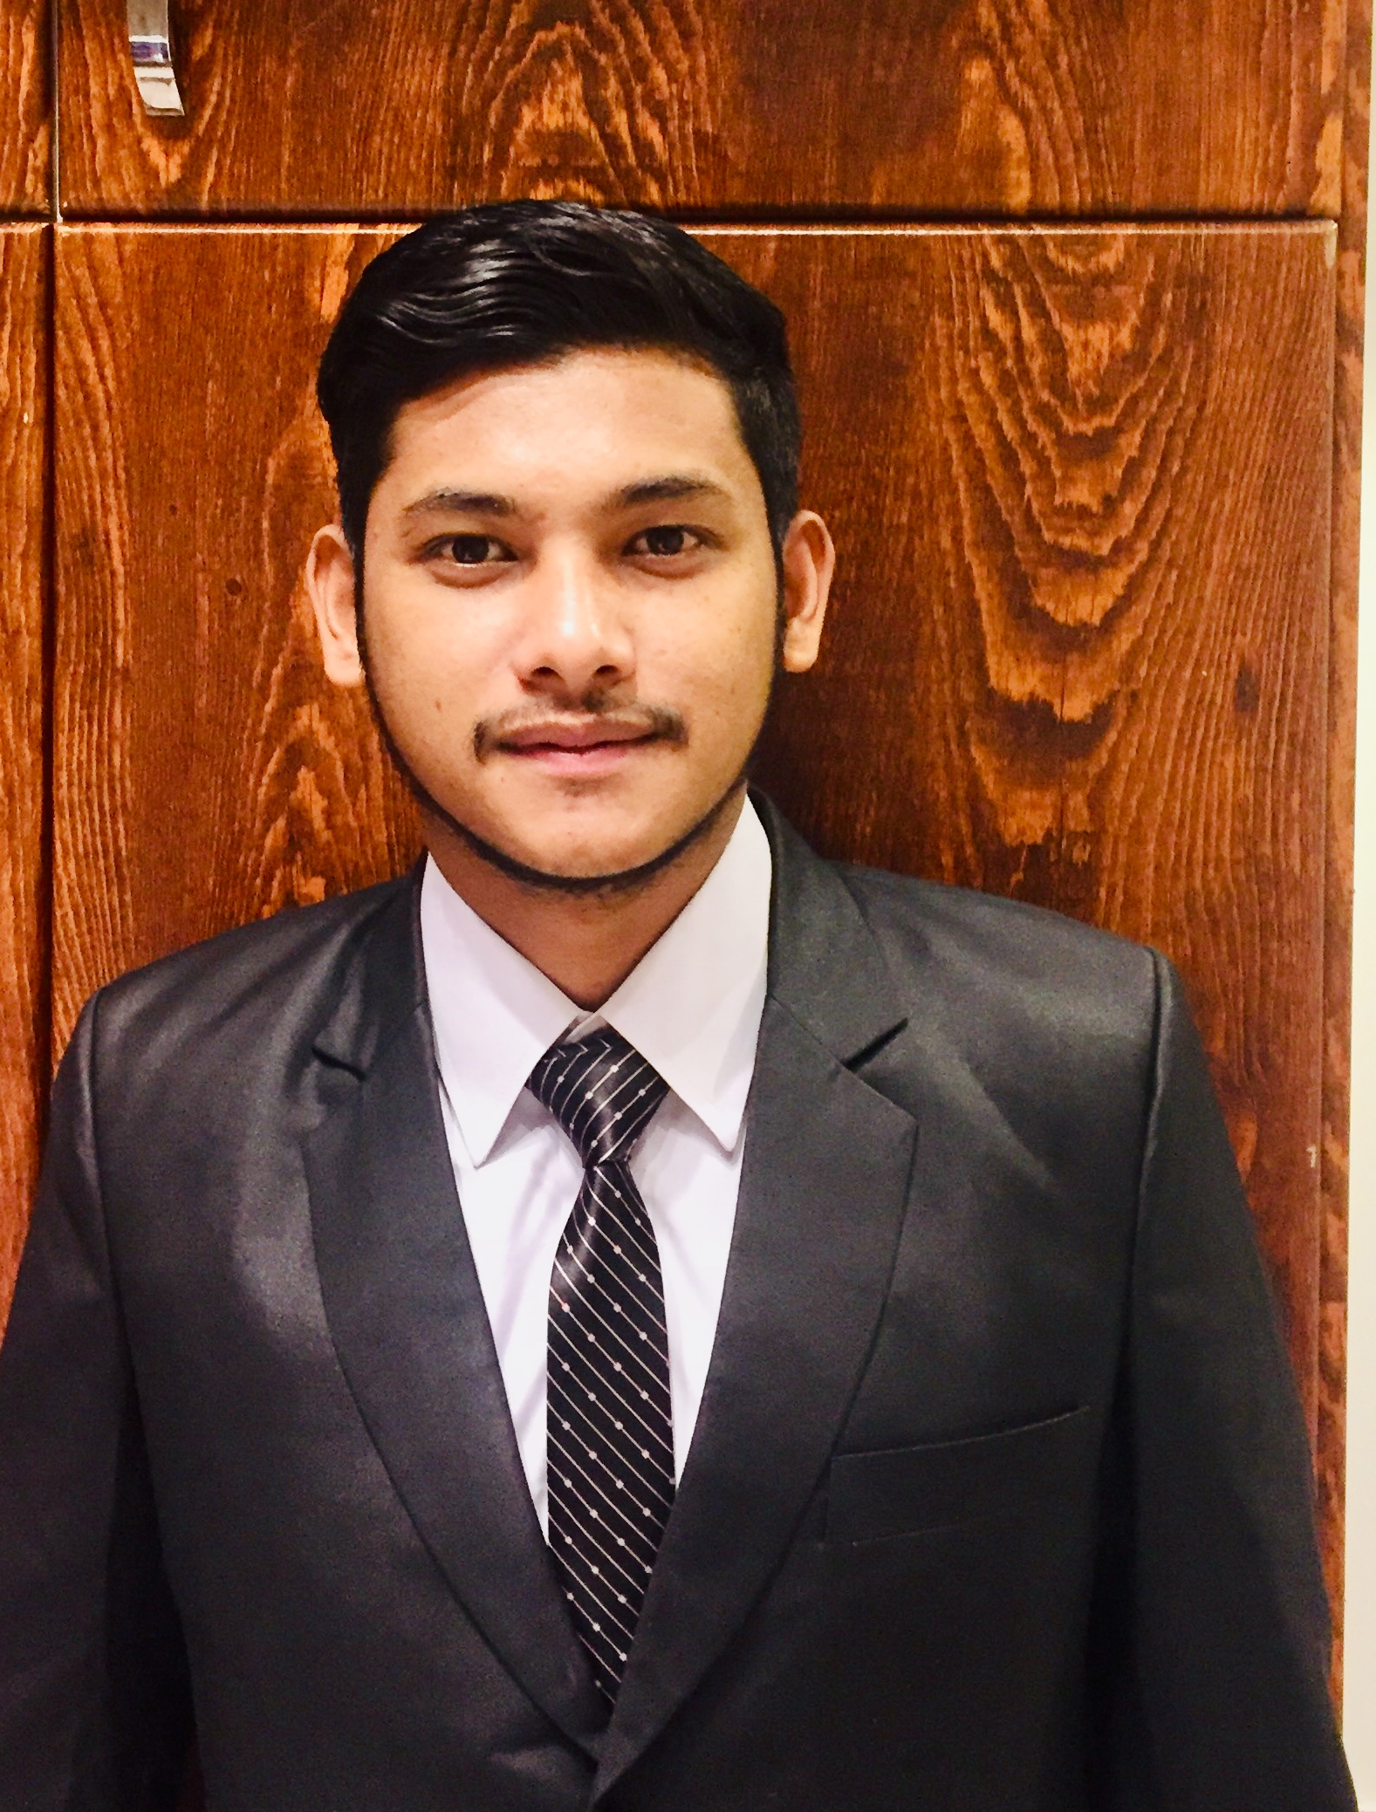 |  |  |  | Asbin Kunwar

Personal information :
- Full Name : Asbin kunwar
- Date and place of birth : 03/11/1999 , gorkha, Nepal
- Nationality : Nepal
- Country of residence : United Arab Emirates , Dubai Sports City
- Marital status : single

Education :

- 2015 : S.L.C from Mahalaxmi higher secondary school
- 2017 : +2 from Reliance international academy
- 2020 : Bachelor in event Management Running from Nest Academy of Management Education Dubai

Working Experience :

- Six month experience of data entry and captcha.
- Eight month experience of Accountain
- 4 month experience of data entry in prime medical center for DHA

Language proficiency :
- English: good at (reading, speaking and writing )
- Nepali

Computer skills & courses :
- MS Office ( Word , Excel, Power point )
- Java and c++

Personal qualities :
- Good physical form
- spirit of group work
- Serious, sense of responsibility
- Good sense of organization and task tracking
- Good customer service

Hobby :
- Reading books
- Playing Football
- Listing Music
- Involve in social work

 |  | Address : Dubai sports city , Zenith tower A1 , Dubai ,united United Arab emirates
 |  | + 971 0566593887
 |  | Email : kunwarasbin98@gmail.com

