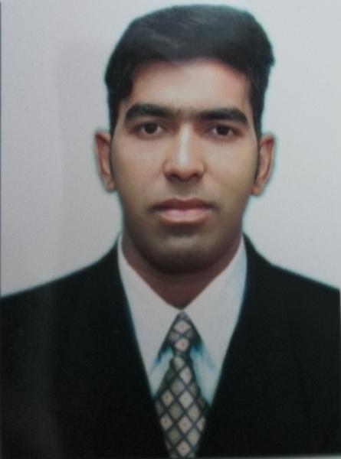
Muhammad Kabir
+97155-621-3710
muhammad.kabir28@outlook.com
Muslim, Single
UAE Light Vehicle & Motorcycle License (1985003)
Employment Visa Dubai (Expire on September-2019)

CAREER SUMMARY

• Knowledge all Dubai road and location • Team Motivation • Time Management
• Team Building • Supervision and Training • Telephone Communications
• Strategic Sales Planning • Expert Product Knowledge • Customer Needs Assessment

EMPLOYMENT EXPERIENCES

DELIVERY COACH / INCHARGE / SUPERVISIOR Present
Man’oushe Street Restaurant (27 September 2015 to current)

RESPONSIBILITIES

- Experience with light vehicles and motorbike.
- Knowledgeable of safety regulations and procedures.
- Ability to plan and organize priorities.
- Accustomed to working under high-stress and harsh weather conditions.
- Strong Customer Relations Skills.
- Delivering an exceptional cashier service through excellent customer servicing
- Sales and transactional processing
- Ability to deal l with large transaction volumes
- Taking money, checks , electronic payment and coupon from to customer
- Analyses and monitor shift wise waste percentage
- Use cash recite machine
- Costumer invoice bill machine
- Performing basic math computations , such as additional subtraction and division

- DELIVERY INCHARGE / CASHIER
Thai Wok restaurant, Dubai, U.A.E (2013 TO 2015)

- HEAD WAITER/ CAPTAIN 2011 to 2013 Dubai, U.A.E
Sultan Place Restaurant

- SALES CORDINATOR (customer service) 2008 to 2011
General & Cosmetics Items Karachi (Pakistan)

EDUCATION

Education Level : College Degree

Education Field : Computer Science / Information technology

English language : Certificate course of Basic computer & Knowledge of Internet

Extra Curses : Hygienic food certificate & PIC Trained

(Person in charge) Dubai

SPECIAL SKILLS

- Microsoft Office™ (Word™, Excel™ PowerPoint™) , Windows™ (7™, Vista™, XP™) , Adobe™, Internet

LANGUAGE

- English – Fluent
- Urdu– Fluent

Personal Detail

Passport no : AE4021332
Father’s name : Orangzaib Khan
Nationality : Pakistani.

Available upon request

