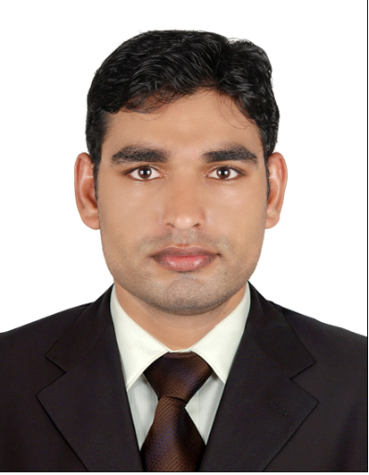Muhammad Shafqat

Mehmood

CONTACT DETAILS
056 6730034
Mshafqat83@gmail.com
Musaffah No.03, Abu Dhabi

PERSONAL INFORMATION
DOB: 6th March 1993, NATIONALITY: Pakistani STATUS: Single
RELIGION: Islam
DRIVING LICENCE NO: 2346315

CERTIFICATES

03 Month Certification in Office Management

SKILLS
- English& Urdu
- Proficiency with scanners andphotocopies.
- Computer – Literate (Microsoft Word, Excel, PowerPoint)
- Monitor andSupervise
- Attending the needsof otheremployees
- PatientCommunicator
- Communication(Written
and Verbal)
- Ability to work under pressure

WORK EXPERIENCE
One Track Delivery LLC
Designation: Fleet Supervisor Cum Accounting Clerk September 23rd 2019 –Present

  - Monitoring inventory of files, paper clips etc. and report shortages.
  - Filing and retrieving documents for other personnel.
  - Streamlining document filing process ensuring their availability at all times.
  - Handling all enquiries related to paperwork/documents.
  - Indexing documents with numbers or codes before filing.
  - Removing or discarding outdated documents as per the company file maintenance procedures.
  - Managing document structuring to ensure easy finding and retrieval when required.
  - Managing all user requests related to document positioning, finding and retrieval.
  - Inspecting the filing section periodically to ensure records are categorized properly and are being maintained in a good condition.
  - Maintaining a log of all outgoing files to ensure documents are returned in time.
  - Digitizing all necessary documentation and store in electronic systems.

EDUCATION:

- Bachelor in Commerce from National Collage of Business Administration and Economics Lahore.

- Computer Application and Office Professional from Vocational Training Institute Lahore.

I hereby declare that the above furnished information is true to best of my knowledge and to assume to render the best service of I am given a chance.

M.Shafqat Mehmood.
Applicant

