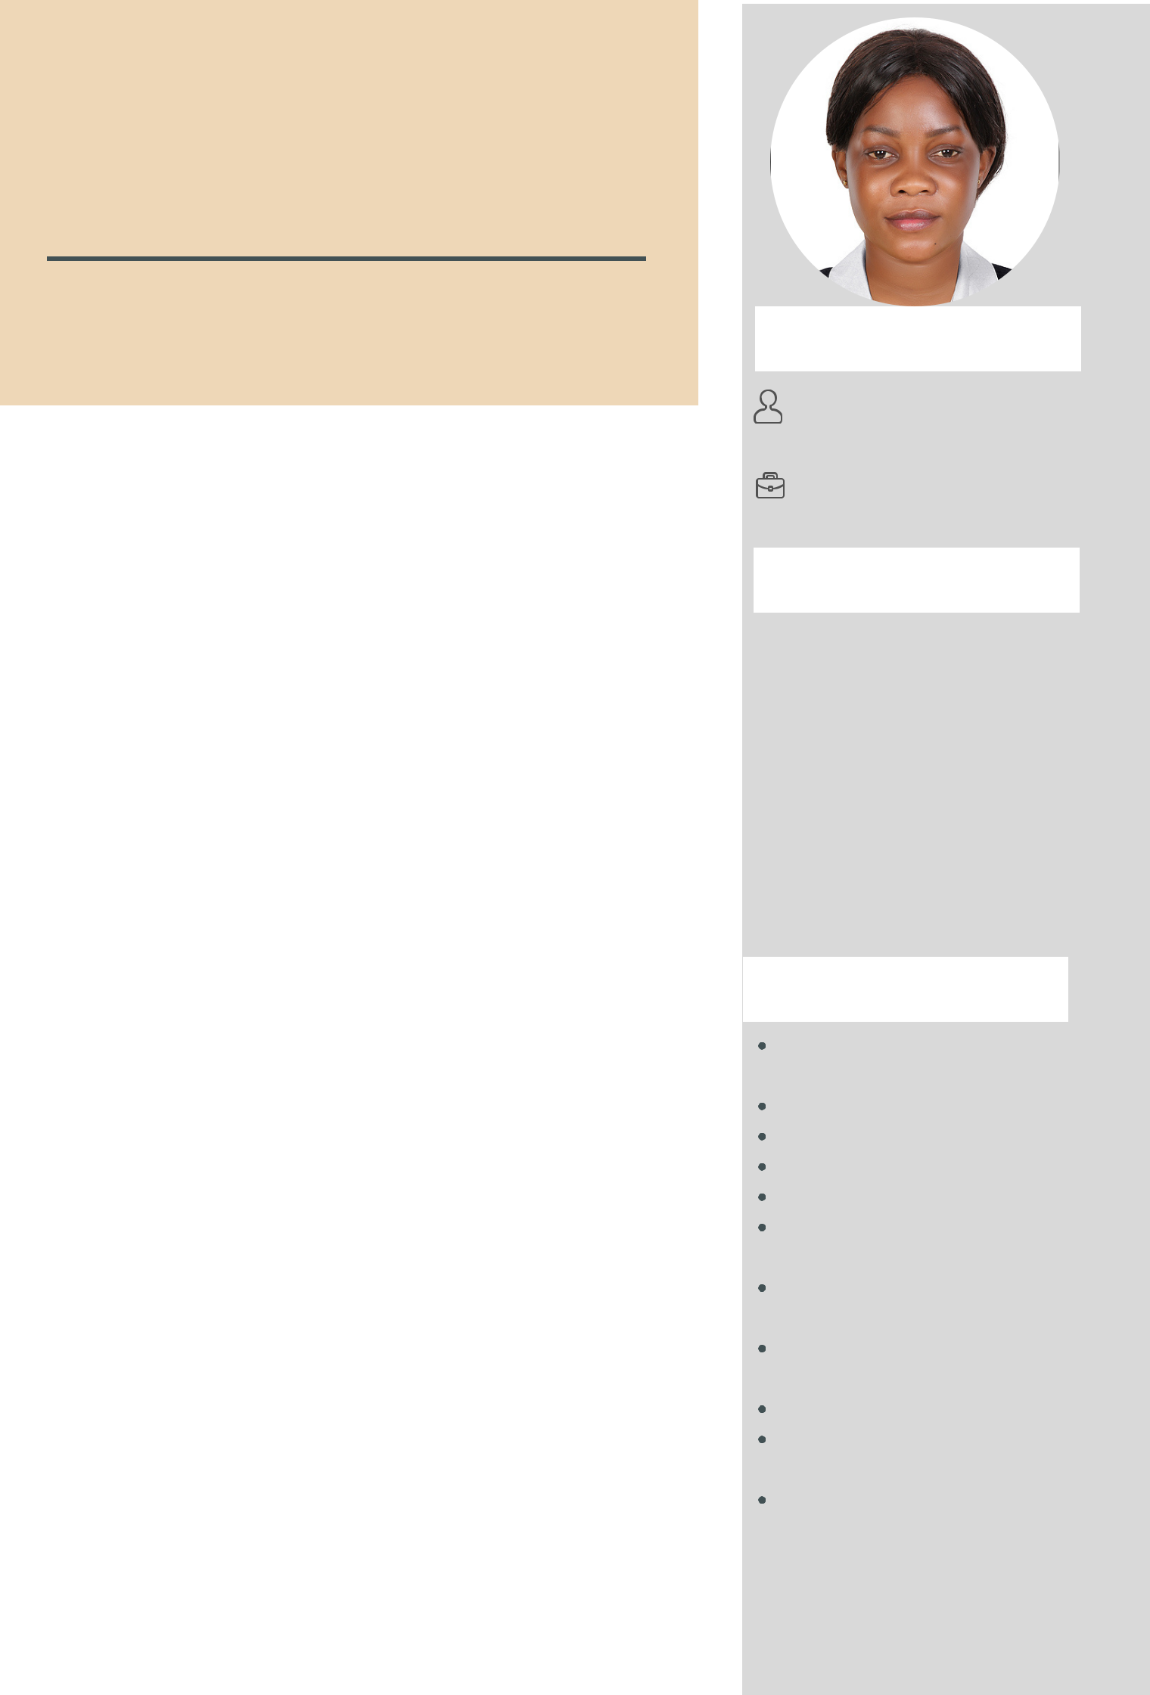
JOSEPHINE NAKIBUUKA

ABOUT ME;

NATIONALITY:UGANDAN

GENDER: FEMALE

AGE: 30

VISA STATUS; VISIT

EXPERIENCE

Dr's Hadi &Hofman Medical Centre Jumeira

DENTAL ASSISTANT NURSE

Preparing fillings and other materials. Providing support and reassurance to the patient.
Sterilising instruments.

Processing and filing x-rays.

Tidying and cleaning the dental surgery. Recording and filing information about

patients.

Advising patients on oral hygiene.

Carrying out stock control.

Training new staff on the procedures

Victoria Hospital Kampala ,Uganda

MID WIFE ASSISTANT

AUG- DEC 2021

2019-2020

CONTACT

0559908114

sunshine.josephine@gmail.com

EDUCATION

2021AMERICAN SAFETY & HEALTH INSTITUTE

BASIC LIFE SUPPORT

MAY 2013-NOV 2016

MULAGO SCHOOL OF NURSING AND MIDWIFERY KAMPALA UGANDA

DIPLOMA IN NURSING

SKILLSET

taking patient samples, pulses, temperatures and blood pressures

caring for and assisting women in labour monitoring and administering medication, injections and intravenous infusions during labour

monitoring the foetus during labour advising about and supporting parents in the daily care of their newborn babies

MULAGO HOSPITAL
2016-2019

IN AND OUT PATIENT NURSE

Prepares and explains procedures to patients; assembles required equipment, supplies and instruments;

then assists physicians with a variety of approved procedures

Floats” to other areas in the hospital as required and skill competency level dictates. Communicates pertinent information following the chain of command

Excellent attention to detail

Cultural awareness

obstetric skills

CPR

Baby care

Great written and verbal communication Ability to carefully read and follow directions Flexibility in work duties and schedule

Good teamwork skills Ability to lift and move patients

Good foundation of clinical skills and knowledge

