CURRICULUM VITAE
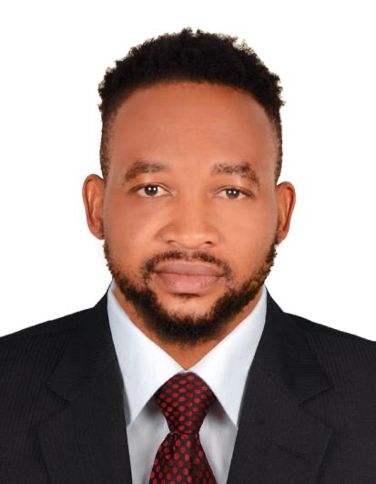

EMMANUEL UZOCHI IGWE

Email: igweuzochiemmanuel@gmail.com
Contact No. +971564731957

Career Objective:

I am a dynamic and highly resourceful professional who is seeking a challenging mid-level position within an innovative organization. My core personal skills are;

Team player: I work collaboratively as an enthusiastic and active team player. Openness to different opinions is fundamental to team success.

Interpersonal: I possess excellent listening, interpersonal, relationship building and networking skills.

Articulate: I hold excellent communication skills (written and verbal) and problem solving skills.

IT: Microsoft Office, MS Projects, Excel, Framework-I and Adobe Photoshop.
I am comfortable with learning and using new systems.

Languages: English

JOB APPLICATION :DIRECTOR| SCRIPTWRITER |PHOTOGRAPHER| VIDEOGRAPHER|DRONE PILOT|GRAPHICS DESIGNER|SOCIAL MEDIA CONTENT CREATOR/MANAGER

WORK EXPERIENCE:

L’OFFICIEL MAGAZINE
https://www.lofficielarabia.com/portfolio/project-runway-haifa-ibn-abbes
PORTFOLIO: https://drive.google.com/file/d/1W56mr6jX8PvC1Z9I2PnvuvbFd6qKH4yc/view?usp=drivesdk

LINK TO INSTAGRAM PAGE
https://instagram.com/simba_films?igshid=18pd1hjkf68ao

DIVA MODELING AND EVENTS (Dubai).
DiOS PRODUCTION (Sharjah)
GEP STUDIOS (Lagos)
SIMBA FILMS (Lagos)

- Create content.
- Write script.
- Directing .
- Budgeting.
- Casting.
- Creative Thinking.
- Multitasking.
- Photography Shoots.
- Videography.
- Pick location of event.
- Photo Editing.
- Meeting with prospective clients.
- Structure the event.
- Coordinate all moving parts.
- Great customer relationship.
- Create positive image for the company.
- Great communications skills.
- Organizing.

Personal Work Attributes:

Solid communication with excellent customer relation
Self-motivated, diligent and hard worker
Adaptable and respective to advise and found of learning.
Respectful and supportive with colleagues
A sincere worker to the tight environment and able to work under pressure

ACADEMIC HONOR
- Senior secondary School Certificate 2005
- Diploma in theater and film 2009
- Bachelor in theater and Film 2014

Computer Proficiency:
Certificate course in MS Offices (MS Excel, MS Word, MS PowerPoint, MS Dos)
Photoshop

Personal Details:

Name: EMMANUEL UZOCHI IGWE
Nationality: Nigerian
Marital Status: Married
Visa Status: Resident freelance visa
Languages Known: English (Can Speak, Write & Read)

I hereby declare & assure that all the above said profile in my application is true and correct to the best of my knowledge.

