NICKEL
MUKHIA
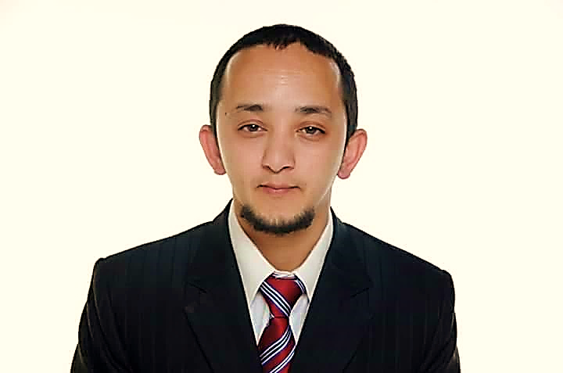 |  |  | NICKEL  MUKHIA

Objective

Attain a position that will enable me to use my strong communication and organizational skills, customer service background, and my ability to work well with others.

Experience

Align Manpower
Operations Coordinator (Oct 2020 - till present)

Lal’s Group (August 2014 – March 2019)
Customer Service Executive
Red Tag (May 2012 – June 2014)
Sales Associate • BMA International FZE

Mt. Carmel School (March 2009 – December 2010)
Assistant Teacher

Mt. Olive’s School (February 2005 – December 2006)
Assistant Teacher

Education
- Passed Teachers Training Course (T.T.C) from Mt. Hermon College of Education. Darjeeling, West Bengal, India (2007-2008)
- Passed I.S.C from Dr. Grahams Homes, Kalimpong, West Bengal, India (2003)
- Passed I.C.S.E from Himali Boarding School, Kurseong, West Bengal, India (2001)

Skills/Abilities
- Communication Skills: • Capable of making communication clearly and effectively through many mediums – by e-mails, Microsoft, verbally, with lists and phone messages, on the phone and with body language • Able to listen and follow directions and provide feedbacks when necessary.
- Personal Traits: • Honest • Flexible • Determined • Persistent • Punctual
- Interpersonal Skills: Able to work in harmony with co-workers and deal with every individuals in a manner that shows sensitivity, tactfulness and professionalism.
- Technical/Soft Skills: • Eager and enthusiastic to learn and enhance skills and knowledge • Able to work under pressure, demonstrate leadership, time management, hard work and dedication • Can use any Microsoft Word processing software • Capable of handling and solving problems or conflicts related to customer complaints and grievances

I hereby declare that all the above information is true and correct to the best of my knowledge and understanding.

References
[Available upon request.]
Villa 205,
Al Mankhool Road,
Al Jafiliya,
DUBAI,
 | (+971) 52-193-3234
-
 | nickelmukhia@gmail.com
PERSONAL INFORMATION:

• DATE OF BIRTH:
5TH APRIL 1982

• PLACE OF BIRTH:
DARJEELING,
WEST BENGAL, INDIA

• NATIONALITY: INDIAN

• GENDER: MALE

• CIVIL STATUS: MARRIED

• PASSPORT #: T4376327

• VISA STATUS: EMPLOYMENT VISA

DIALETS SPOKEN:
• English • Nepali • Hindi • Bengali.

HOBBIES/INTERESTS:
• Photography

TRAININGS ATTENDED:

• First Aid (Certified)
• Telephone Etiquette
• Time Management
• Goal Settings
• Conflict Resolution
• Stress Management
• Fire Drill

