
MARIYAM MUHAMMAD MUSLIM

UAE Resident

0509777598

mariyammuslim89@gmail.com

linkedin.com/in/mariyam-mohd
To be a remarkable presence with all possible challenges and pressures. Innovating approaches for providing solutions and using my expertise to serve the purposes of the company. Enhancing knowledge and skills with change in time and style
Academics & Qualifications

- MBA – Masters in Business Administration in Management (Australia, 2020- Present)
- BBA – Bachelor in Business Administration in Finance (USA, 2010)

Professional Experience

First Abu Dhabi Bank – Dubai, UAE (Dec 2017 – July 2020) Business Development Unit Officer (Retention)

Core responsibilities:
- Utilizing consultative approach by Retaining customers from cancelling credit cards and Insurance on cards, presenting the benefits and key features of the products effectively to acquire sales and retention.
- Multi-tasking in different retention activities.
- Cross sell banking products.

Etisalat – Ajman, UAE (Jan 2013 – Sept 2017) Senior Customer Service Representative (Sales and Retention)

Core responsibilities:
- Promoting the new mobile packages of Etisalat to the customers.
- Processing of those services to the customers.
- Activation of billing address.
- Selling all the new products and services launched in Etisalat.
- Cross sell of Etisalat products and services.

Proudly certified in:

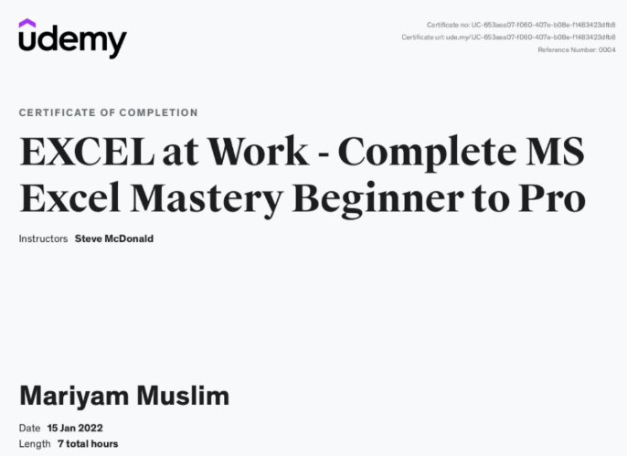

Certifications can be validated here: https://www.udemy.com/certificate/UC-653aea07-f060-407e-b08e-f1483423dfb8/

