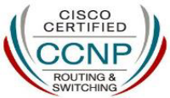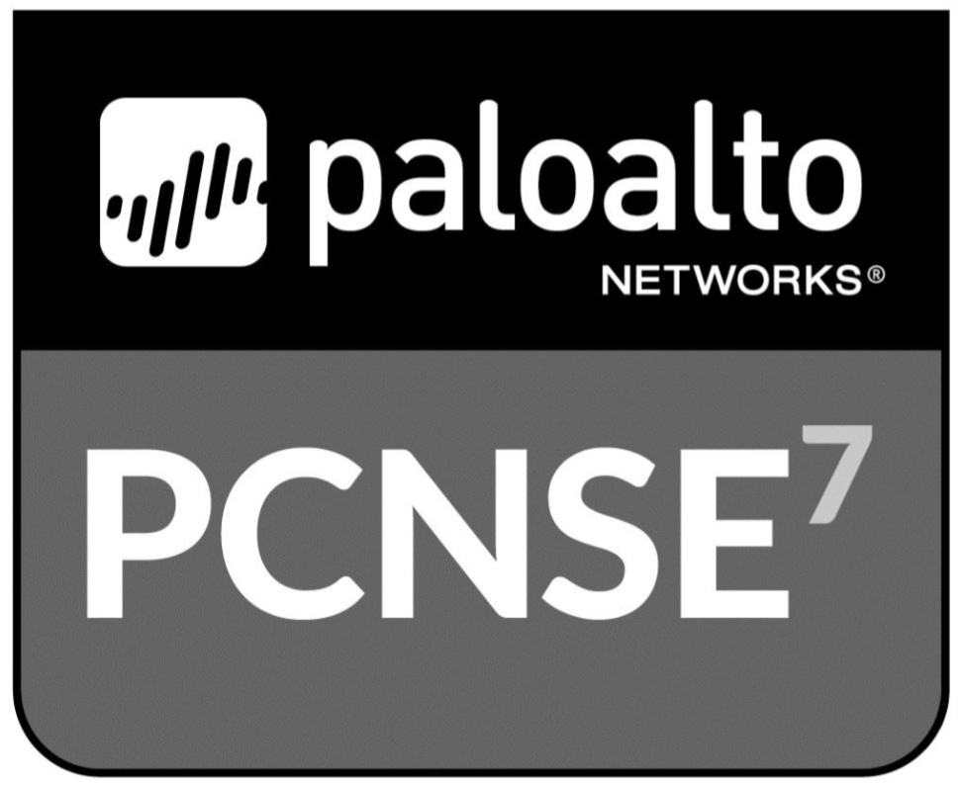SHINU JOSEY

Dubai, UAE

Mobile: +971 544056220

E-Mail: shinujosey@yahoo.com

OBJECTIVE:
Proven record of achievement in conceiving & implementing effective ideas; targeting senior level assignments in Server & Network Administration / IT Infrastructure Management with a leading organization of repute

PROFESSIONAL SYNOPSIS:
- Dynamic career of 13 years that reflects rich experience and year-on-year success in Server & Network Administration and IT Infrastructure Management for various networking and windows server administration endeavours:
- Planning Network Administration activities involving management of complex network design, configuration, deployment & troubleshooting
- Suggesting improvements to make the system fool-proof & providing technical support to clients; finalizing specifications of new features to ensure that network resources are used effectively
- A forward thinking person with strong communication, analytical & organizational skills, well organized with a track record that demonstrates self-motivation & creativity to achieve corporate & personal goals

Area of exposure:
- Firewalls: PaloAlto 5020, Cisco ASA 5510, FortiGate 200E,
Cyberoam CR750ia, CR100i, CR50i, 25wi & Cisco PIX 525
- L2 & L3 Switches: Cisco 9407R, Cisco 4507R+E, Cisco Catalyst switches 3850, 3560, 2960,
2950 & HP management switches
- Routers: Cisco 2911, 2821, 2511, 1841 & 800
- Virtualization: VMware ESXi 6/5, VSphere 6/5, Xenserver 6/5, Citrix Xen Server,
VMware Thin App & Citrix XenApp
- Technologies: MPLS, Internet Leased Line, IPSec, Cisco VPN,
Cisco AnyConnect, VLAN, VTP, STP, HSRP, GLBP, NTP, IP SLA,
Policy Based Routing, Ether Channel, ACLs, Cisco ACS, Active Directory,
DNS, DHCP, WINS, WSUS and ADMT
- Monitoring Tools: PRTG, Wireshark, Solar-winds , GFI Events Manager, GFI
LanGuard, Kiwi Syslog, Manage Engine for Netflow Analyzer, OPUtil,
OPManager, AD Manager Plus & Firewall Analyzer
- Operating System: Windows Server 2016, 2012, 2008 and 2003
- Servers: HP ProLiant, Dell PowerEdge, Fujitsu-Siemens Blade BX620 & 920

EDUCATION:
- BCA (Bachelor of Computer Application) from Bharathiar University, India
- CCIE R&S Written Passed
- CCNP (Cisco Certified Network Professional)
- PCNSE 7 (Palo Alto Networks Certified Network Security Engineer)
- CCNSP (Cyberoam Certified Network & Security Professional)
- MCSE (Microsoft Certified Systems Engineer)
- MECPA (ManageEngine Certified Product Associate)
WORK HISTORY:

No | Designation | Name of the Organization | Location | Period
 |  |  |  | From | To
1 | Sr. Network & Security Engineer | Annuncio International Advertising | Kerala, India | Nov 2019 | May 2022
2 | Sr. Network Consultant | Ajman Free Zone Authority | Ajman, UAE | June 2018 | Oct 2019
3 | Sr. Systems Engineer | Darwish Bin Ahmed & Sons | Abu Dhabi | June 2011 | May 2017
4 | Network Engineer | Sembawang UAE Pvt. Ltd. | Dubai, UAE | Sep 2009 | Oct 2010
5 | Sr. Network Administrator | A&P Engineering | Ajman, UAE | March 2006 | July 2008

CAREER HIGHLIGHTS:

Nov 2019 – May 2022 Annuncio International Advertising as Sr. Network & Security Engineer

Company profile: Annuncio International Advertising company provides services like IT AMC Support Services, Graphic Designing, Web Designing, 2D/3D Printing, Mobile App Development and Social Media Marketting.
Responsibilities:
- Implemented Fortinet Firewall for Endusers traffic management
- Managed key vendors, schedule expenditures, forecast requirements and IT Budgeting
- Provided user support in appropriate use of systems, applications, internet & intranet usage and best possible solutions to IT related issues
- Routine health checkup on IT infrastructure components to identify issues and conduct preventive maintenance to reduce potential downtimes and risks
- Drove Daily & Monthly Backup of Servers using the software “Acronis Backup & Recovery Software”

Jun 2018 – Oct 2019 Ajman Free Zone Authority , under (Param Info) as Sr. Network Consultant

Company profile: Ajman Free Zone is a free trade zone in Ajman, UAE. First established in 1988, it is one of a number of unbonded free zones in the UAE offering offshore company setup and operation to investors.
Responsibilities:
- New Datacenter has been implemented in Ajman Free Zone Headoffice with Tier-2 IT Industry Standards
- Spearheaded & managed:
- Installation, configuration, and management of Cisco Core Switch C9407R
- Configured VLAN, NTP, Policy Based Routing, Port Channel, ACL and Static routes in
Cisco Core Switch
- Implemented Network Access Control system with Aruba Clearpass
- Implemented F5 Load Balancer for Application load balancing in Oracle
- Coordinated with ISP (Du and Etisalat) for MPLS, Lease line and ADSL connections

Jun 2011 – May 2017 Darwish Bin Ahmed & Sons, Abu Dhabi, UAE as Sr. Systems Engineer

Company profile: DBA InfoTech is the IT Division of the Darwish Bin Ahmed and Sons entire group. It has emerged as a separate company over the years and has delivered solutions to a number of external and internal clients. DBA Infotech delivers solutions in various areas of Software and Hardware.
Responsibilities:
- Developed an industry standard IT infrastructure for the organization. This includes managing of corporate Datacentre in Abu Dhabi, as well as remote offices in all regions of UAE, Australia, New Zealand, Greece, Saudi Arabia, South Africa and India
- Lead a Team of 10 employees and accomplished the seamless functioning of Network, Systems and Security to adjust & improve network performance and investigate issue & root cause of system failure
- Spearheaded & managed:
- Configured Cisco ASA 5000 series firewall for Site-To-Site VPN, Publishing the Oracle Applications on Internet Leased Line connection, VPN Access to End users etc
- Implemented Palo Alto Firewall v5520 for DMZ network
- Configured Cisco Wireless Controllers v5508 with 25 Cisco Access Points
- Configured Cyberoam CR750ia for Internet firewall and IPSec connectivity with remote offices in UAE
- Configured MPLS, Internet Leased Line and Point-to-Point Leased Line connection
- Implemented NAP (Network Access Policy) in Active Directory
- Citrix XenApp v6.5 has been configured for publishing applications on Internet
- Implemented and managed Windows Active Directory Servers with 1 PDC & 50 ADC’s on remote sites for supporting 1500+ client computers
- Configured Cisco Access Control System (Cisco ACS) for managing Cisco Devices with TACACS+ authentication
- Configured NTP, HSRP and WSUS
- Leading design and configuration of Virtualization Servers using VMware and Citrix Xenserver
- Managed Office365 cloud which has been integrated with local Active Directory Server for user synchronization and licensing
- Implemented Central File Sharing Devices running on NAS and Daily Backup of EDR File Server
- Daily monitoring of network devices & servers using Manage Engine, Solarwinds, GFI Events Manager, GFI LAN Guard and Kiwi Syslog

Sep 2009 – Oct 2010 Sembawang UAE Pvt. Ltd., Dubai, UAE as Network Engineer

Company Profile: Sembawang (Subsidiary division of Punj Lloyd) is one of the leading construction company having operations in Middle East and Africa.
Responsibilities:
- Managed Network & Server Devices of HQ & site offices
- Led Lotus Notes Mail Server, Microsoft Active Directory, DNS, DHCP, WINS, Print Server & FTP Server
- Spearheaded Cisco IP Phones
- Drove daily & monthly tape back-up of Windows Server using the software “Symantec Backup EXEC 10”

Mar 2006 – Jul 2008 A&P Engineering, Ajman, UAE as Sr. Network Administrator

Company Profile: A&P Engineering (Subsidiary of M/s A&P Group, UAE) is an 80 million turnover corporate Group Established in 1980. The group consists of 4 companies catering to the construction & engineering related industry with main offices in Ajman and other major emirates with approximately 25 remote sites located across United Arab Emirates.
Responsibilities:
- Worked as an ERP Coordinator by providing support and maintaining ERP system for the corporate group
- Worked as interface between end users and System Development Team
- Managed Cisco Routers, Switches & PIX Firewall
- Trained & supported the Department staff for ERP Application access
- Configured & managed Citrix Presentation Server 4.5 /4.0
- Troubleshoot problems arising from hardware, network infrastructure and security related
- Drove Daily & Monthly Backup of ERP Application using the software “Brightstor Arc Server”

PERSONAL DETAILS:

- Date of Birth: 24th December 1980
- Languages Known: English, Hindi, Malayalam and Tamil
- Marital status: Married with one child
- Nationality: Indian
- Contact Number: +971 544056220
- Visa Status: On Visit visa

DECLARATION:
I hereby declare that the information given by me above is correct and true to the best of my knowledge and belief.

Shinu Josey

