CURRICULUM VITAE
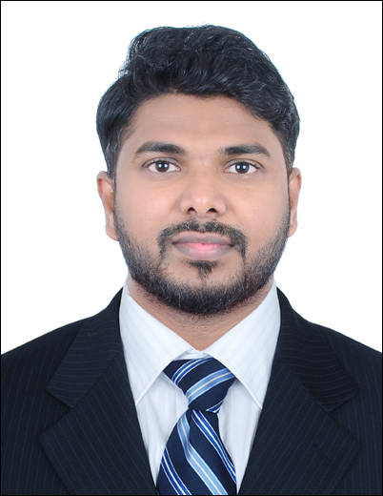 KARTHIK MONY
E-Mail Id : karthikish89@gmail.com
Mobile (India) : +91 7200556062
Mobile (UAE) : +971 525506908
Skype Id : karthikish89
Father’s Name : Mr. MONY
D.O. B : 09:05:1986
Nationality : Indian
Languages
Known : English,Tamil, Hindi, Malayalam.
Educational qualification:
- M.Sc NURSING Rajiv Gandhi University of Health Sciences
- B.Sc. NURSING &MIDWIFERY M.G.R. University.
Address for Communication:
Honey building, Rolla Sharjah, United Arab Emirates.
Permanent Address:
No 8/2b, Palace Road Puliyoorkurichy, Thuckaly (Po)Kanyakumari District, Tamilnadu India.
Pin code: 629 174
Passport Details
Passport Number: H8992798
Project Title:A Study to Assess the Effectiveness of Structured Teaching Programme On Knowledge and Practice

Objective:
A job in the field of Nursing with Medical Insurance & Billing with the opportunity of specialization to acquire more knowledge with continued strive for improvement and to deliver medical care in the highest order through uncompromising quality and dedication.
Current Designation:
- DUBAI HEALTH AUTHORITY, DUBAI HOSPITAL United Arab Emirates,since from 2019 to 2020. Medical Insurance officer.
Previous Experience:
- PRIME HOSPITAL, Airport Road, Al Garhoud, United Arab Emirates, since from May 2014 to 2018. Medical Insurance & Billing Processes.
(Years of Experience: 5 Years)
Professional Summary:
Medical Insurance & Billing Specialist with 6 years of experience to serve in a position where my diverse medical knowledge, skills and expertise can be utilized within a company.
Responsibilities:
- Hospital based insurance & billing processes.
- Hospital based IP & OP approvals submission to the Insurance companies.
- Coordinating with major insurance companies among UAE for approvals for OP & IP patients
- Responsible for submitting bills to insurance companies. Ensures follow-up regarding insurance payments.
- Following up with Hospital Insurance Team for necessary updates on the insurance status of the admitted patient and arrange for the necessary documents to be submitted as per requirement by insurance.
- Issues invoice by entering service data; calculating charges; mailing invoices.
- Responsible for Billing Insurance and non-insurance Invoices.
- Responsible for obtaining approvals/pre-authorization from Insurance companies.
- Coordinating with nurses to make sure the discharge timings are maintained and to follow for insurance extension for overstayed patients. Keeping Track of Timely extensions with no of days. Verification of accurate CPT code with the coder.
- Resolves billing issues by discussing contract with third-party payer; explaining insurance contract with patient; negotiating settlement.
- Hospital based knowledge of RCM , HIS & YASASII

Previous Experience
1.Nurse, Post: Intensive Care Unit Nurse
Nims University Hospital
Shobha Nagar, Jaipur - 303001
(Years of Experience: 2 Years)
- Responsible for the working in the night shift and on-call nurse when required.
- Monitored CVP and BP, drawing arterial blood gases and take care of the arterial lines.
- Acted as the medical care and specialized nurse for 10-bed unit.
- Responsible for the calculating and recording the high alert medication.
- Treated patients who were recovering from the surgeries.
- Responsible for the recording and reporting values of laboratory with the medical treatment.
- Monitored GCS.
2. Occupational Health Nurse,
TVS Company Sundram Fasteners Limited,
Padi Chennai- 600050
(Years of experience: 1 Years 6 months)
SKILLS:
• Great observational skills
• Ability to handle a large group of people
• Excellent computer skills
• Outstanding nursing knowledge
• Wide knowledge in disease and accident prevention
TASKS
• Maintained health record of all employees.
• Developed a program that will help injured employees to recover faster.
• Assessed the workplace of the employees.
• Monitored and recorded the progress of employees who were exposed to hazardous chemicals.
• Changed bandages and wrapped wounds.
• Ensured that the company adheres to the health and safety program set by the BFAD.
• Conducted periodic health assessments to employees.
• Delivered talks on health care and disease prevention.
• Treated employees exposed to the chemicals.
Computer Skills:
- Ms Office (Word, Excel, Power Point)
- Ms Outlook
- Windows XP, Windows 10.

DECLARATION
I declare here by that all the information given above is true to best of my Knowledge.
Yours Sincerely
KARTHIK MONY

