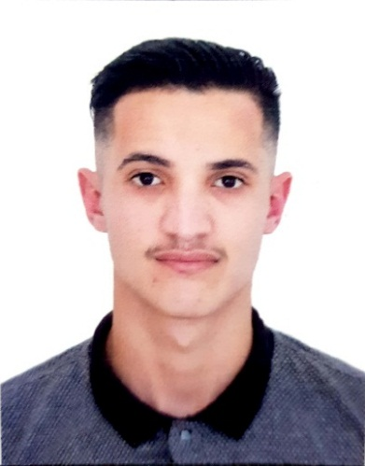  PersonaL QUALITy:  - Good physical condition  - spirit of group work and initiative  - Good sense of organization  - Serious and sense of responsibility  - Very good morality and human relation  Computer skills & COURSES:  - PASCAL, CC++, ( good user )  - MS Office (word , Excel )  - Quality & safety Training | training and diplomas acquired:  - 2018-2019 : Obtaining baccalaureate in Technical Math.  - 2019-2020 : first year bachelor in computing at the university of Mouloud Mammeri, Tizi Ouzou.  - 2020-2021: Student at Nest Academy of Management Education in computing.  Professional experience  Languag PROFICIENCY:  - English : very good, ( read ,spoken and written) .  - Arabic : Excellent, (read ,spoken and written) .  - French : Excellent, (read ,spoken and written) .
  wassim chikhaoui
  - 1 Year customer service agent with “KITOPI” in World Trade Center.
  - 3 Months as waiter on “MARKETTE” restaurant in Dubai Mall.
  - 2 Years selling experience in a supermarket.
  - 3 years selling experience in mobile phone and accessories store.

